

CW1 - Software Product Planning Assignment

Stage 2 - MVP and Sprint Plan

Project: Family Travel Companion

Team Number: F3

Module Details
Course/Module: COM435 - Software Product and Process Management

Team Members
Team Number: F3

Contributing Team Members (list below: Surname, first name (Student ID)):

1. Contributing Team Members and Roles
Name | ID | First Role | Second Role | Contribution
MD Ali Hasan Jidan | B01011849 | Backlog Coordinator | UI/UX Designer | Authored Feature 3 wireframes (Upload Documents); led development task creation for S6; produced 3 test cases for S6.
Habibur Rahman | B01009639 | Scrum Master | Developer | Maintained Trello board, facilitated all sprint ceremonies, designed Feature 2 wireframes (Book Accommodations); authored development tasks for S4 and S7; contributed 3 test cases for S4.
Md Jahirul Islam | B00999362 | User Story Writer | Risk Analyst | Authored MVP description and introduction; produced wireframes for Feature 4 (Manage Budgets); development tasks for S5; test cases for S5.
Komalpreet Kaur | B01015647 | Documentation Lead | QA Analyst | Compiled and formatted final report; authored Feature 5 wireframes (Coordinate Group Trips); development tasks for S15; test cases for S15 and S16.
Sheheryar Khan | B01010078 | Spike Writer | Quality Checker | Reviewed all artefacts for consistency; authored Feature 6 wireframes (Shared Itineraries); development tasks for S2; test cases for S2 and S21.
Syed Abdul Hafeez | B01012379 | Spike Investigator | Developer | Authored Feature 7 wireframes (Redeem Rewards); development tasks for S28 and S27; test cases for S28 and S27.

2. Introduction
This report constitutes Part 2 of the CW1 Software Product Planning assignment for COM435. It presents the Minimum Viable Product (MVP) definition, a five-sprint story map, interface wireframes with design rationale, detailed development tasks, and a comprehensive set of test cases for the Family Travel Companion platform.
Family Travel Companion is a versatile mobile and web platform that brings together all family travel experiences under one roof. Smith and Chen (2023) through their study, pointed out that one of the major issues in family travel is the absence of one tool that can allow collaborative work of family members conjointly. Besides that, Johnson et al. (2024) in their research revealed that families today expect travel tools to give them a feature through which they can make real-time synchronisation, financial monitoring, and document management, which are considered to be a success factor. In addition, the Travel Technology Association (2025) states that although 78% of families use digital tools for travel planning, 65% of them still feel lack of coordination capabilities, thus Family Travel Companion is designed to meet this demand gap in the market.
The report is based on the Agile Scrum principles that the Scrum Guide (Schwaber and Sutherland, 2020) outlines. The story map allocates all 30 user stories to five two-week sprints, giving priority to the most valuable family-facing features in Sprint 1 and Sprint 2, and gradually rolling out partner, administrative, and gamification features in subsequent sprints. Sprint 2 has been executed and its outputs form the empirical basis for refining Sprint 3–5 planning herein. The wireframe layouts incorporate 3-ups and 1-ups sketching methods as suggested by Buxton (2007) to make certain that design choices are based on a thorough comparative analysis rather than sudden creativity. Test scenarios are designed to correspond exactly with the acceptance criteria situations set out in Part 1, thus providing complete traceability from user requirement to verification.
3. Minimum Viable Product (MVP) Description
The MVP for the Family Travel Companion platform delivers the essential features required to support a complete family travel planning cycle. It allows families to search for destinations, collaboratively build a shared trip itinerary, track a trip budget in real-time, book accommodations and activities, and securely upload travel documents.
The MVP's goal is to make a product that families can use, find useful, and test that lets them plan their whole trip from start to finish.

MVP Objectives
- Enable families to collaboratively plan trips in one platform
- Simplify booking and financial tracking
- Ensure secure storage of travel documents
- Provide a seamless and user-friendly experience
- Validate core assumptions through real user interaction

MVP Core Features

1. Search for Family-Friendly Destinations (S1):
People can look for and learn about travel destinations by using:
- Search by keyword
- Filters by category, like beach, city, or nature
- Visual cards with ratings, prices, and badges for age-appropriateness
- Map view that is built in for geographic awareness
This feature makes it easy for families to find places that everyone can enjoy.

2. Make and change shared trip plans (S2):
Families can work together to make and keep track of their travel plans:
- A timeline of your daily itinerary
- Collaboration in real time with more than one user
- Scheduling activities with time slots
- Finding conflicts in plans that overlap
This makes sure that family members work together smoothly.

3. Keep an eye on and manage trip budgets (S5):
Users can keep an eye on and manage their travel costs:
- Set a budget for the whole trip
- Set budgets by type, like food, lodging, and so on.
- Keep track of your spending in real time
- Get alerts when you're close to your budget limits
This feature helps keep money matters open and stops people from spending too much.

4. Book Accommodations, Transport, and Activities (S4)
Users can browse and make bookings within the platform:
- Categorized booking (Stay, Transport, Activities)
- Detailed listings with price, ratings, and features
- Add-to-basket functionality
- Centralized booking confirmation
This provides a convenient all-in-one booking experience.

4. Book Accommodations, Transport, and Activities (S4):
Users can search for and book things to do on the platform:
- Booking by category (Stay, Transport, Activities)
- Full listings with prices, ratings, and features
- The ability to add items to a basket
- Booking confirmation in one place
This makes booking easy by putting everything in one place.
5. Upload and Sort Travel Documents (S6):
Users can safely handle important travel documents:

- Put your tickets, passports, visas, and insurance online.
- Put papers into folders
- Get alerts when something is about to expire
- Get to documents without being online

This makes sure that important papers are always safe and easy to get to.

MVP Exclusions
The following features are intentionally deferred beyond the MVP to reduce initial scope and risk: partner-facing service listings and promotions (S7–S14), group trip coordination for organisations (S15–S17), tourism board content (S18–S20), corporate eligibility verification (S21–S23), platform administration tools (S24–S26), and gamification (S27–S30). These are sequenced into Sprints 2 through 5 based on stakeholder priority and technical dependencies.

The MVP reflects the principle of delivering the highest user value with the smallest scope, enabling early feedback loops before investing in partner and administrative complexity (Beck et al., 2001).

4. Story Mapping
The story map below distributes all 30 user stories across five two-week sprints. Stories are grouped under four themes and their associated features, prioritising core user-facing functionality in early sprints and partner/admin features in later sprints.

Themes | User Experience & Planning |  |  | Booking & Finance |  | Partnerships & Content |  |  | Engagement & Compliance
Features | F1: Family Members | F5: Tourism Boards | F7: Admins | F1: Family Members | F6: Corporate Partners | F2: Travel Businesses | F3: Local Hosts | F4: Edu Orgs | F8: Gamification | F6: Corporate Partners
Sprint 1 | S1: Search family destinations | S18: Publish curated itineraries | S24: Verify partner listings | S3: Coordinate family schedules | S22: Verify user eligibility | S7: Create service listings | S11: List tours & activities | S15: Coordinate group trips | S30: Earn points & badges | S21: Create perk bundles
 | S6: Upload travel documents | S19: Transport & accessibility info | S25: Moderate content & reports | S5: Manage trip budgets |  | S8: Real-time availability | S12: Set schedules & pricing | S16: Manage digital waivers | S27: View family progress
 | S2: Create & edit shared itineraries |  | S26: Manage user support
Sprint 2 | S4: Book accommodations, transport & activities | S20: Real-time updates (weather) | S24: Partner quality checks | S5: Budget alerts & warnings | S23: Track redemption analytics | S9: Offer targeted promotions | S13: Communicate pre-event | S17: Track attendance & comms | S28: Redeem points for rewards | S22: Eligibility verification flow
 | S7: Create & manage service listing |  |  |  |  | S10: Process & confirm bookings | S14: Gather post-event feedback |  | S29: Family challenges & leaderboards
Sprint 3 | AI-powered trip personalisation (smart destination & activity suggestions based on family profile) | Interactive destination guides (multimedia travel guides with offline access) | Partner verification dashboard (automated compliance scoring for listings) | Multi-currency budget management (live FX conversion & multi-currency expense tracking) | Corporate perk analytics portal (usage dashboards & redemption reports for partners) | Dynamic pricing engine (real-time price adjustment based on demand & season) | Host messaging system (in-app chat between hosts & booked families pre-event) | Digital consent management (minor co-signature & guardian email verification flow) | Privacy & data controls (per-user visibility settings for gamification data) | Corporate HR portal integration (SSO eligibility sync with employer HR systems)
 | Collaborative conflict resolver (merge-conflict UI for simultaneous itinerary edits) |  |  | Over-budget smart alerts (threshold warnings with cheaper-alternative suggestions) |  |  |  | Points expiry notification system (scheduled 30-day & 7-day expiry alerts) | Points expiry warnings
Sprint 4 | Offline document sync (background cache sync for travel documents when reconnected) | Accessibility enhancements | Automated issue resolution (rule-based ticket routing & chatbot for common queries) | Waitlist & capacity management (auto-notify families when spots free up) | Advanced redemption analytics (partner-level usage trends, CSV exports, scheduled reports) | Dynamic pricing integration | Post-event feedback system (star ratings, written reviews & host response tools) | Post-event feedback system (star ratings, written reviews & host response tools) | Leaderboard & challenge engine (configurable family challenges with anti-cheat rules) | HR portal integration
 | Family memory albums (collaborative photo & note albums tied to trips)
Sprint 5 | Full platform integration & testing | Cross-feature itinerary & guide links | End-to-end platform quality assurance | Multi-currency budget reporting (exportable trip cost reports with FX summaries) | Full perk program reporting | Partner analytics dashboard (revenue, booking trends & audience insights for businesses) | Experience review & rating system (verified post-stay reviews displayed on host listings) | Group trip compliance reporting (auto-generated waiver archives & attendance compliance docs) | Gamification balancing & anti-exploit (duplicate-action detection & admin override controls) | B2B onboarding automation (guided partner onboarding wizard & auto-provisioned credentials)
 | Performance optimisation & UX polish (API profiling, bundle-size reduction & final accessibility audit)

5. Design
Selected Seven features from Sprint for wireframe design using 3-up and 1-up sketching methods.

Selected Features
Team:
Feature 1 – Search for Family-Friendly Destinations
Individual:
Feature 2 – Book Accommodations, Transport & Activities
Feature 3 – Upload and Organise Travel Documents
Feature 4 – Manage and Track Trip Budgets
Feature 5 – Coordinate Group Trips and Schedules
Feature 6 – Create and Edit Shared Trip Itineraries
Feature 7 – Redeem Points for Rewards

Feature 1 – Search for Family-Friendly Destinations
Assigned to: Team (All Members) | User Story: S1 – Search family destinations

3-Up wireframe

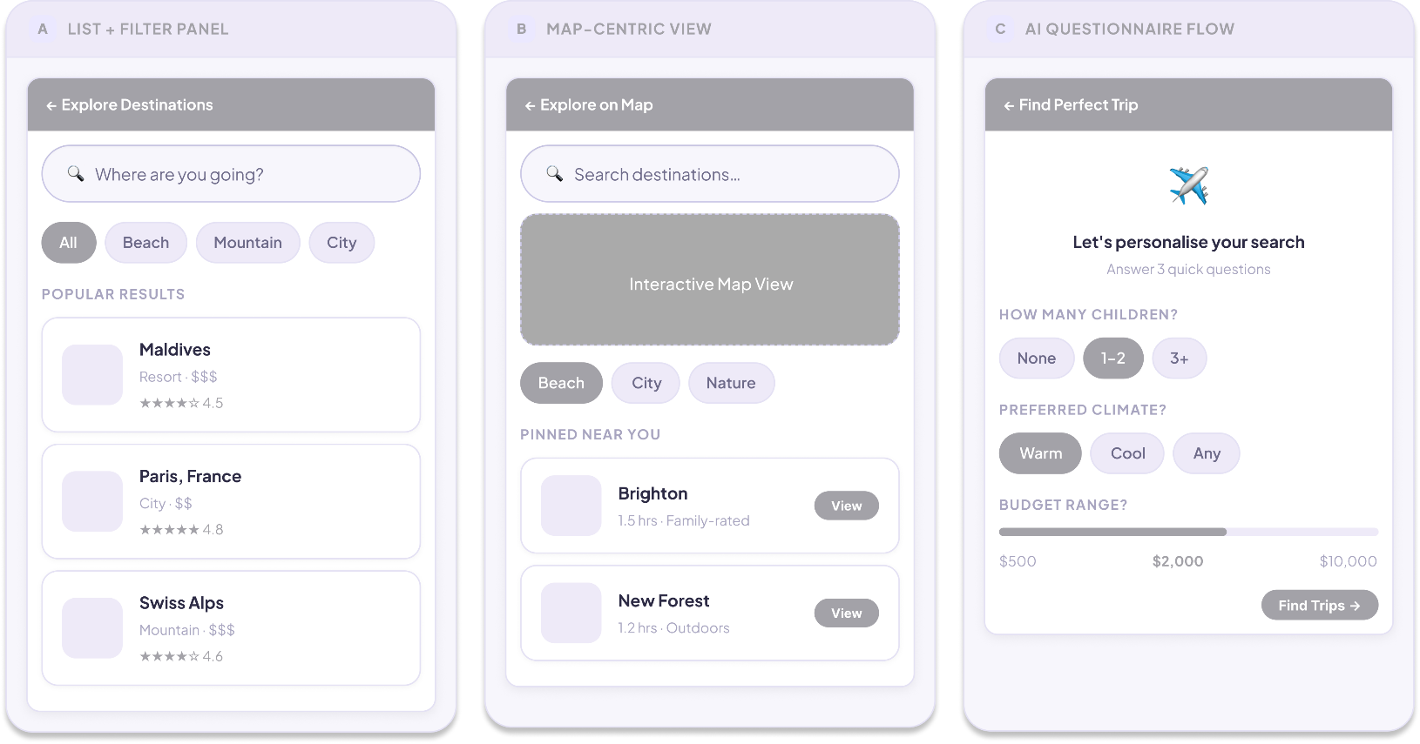

1-Up Fina design

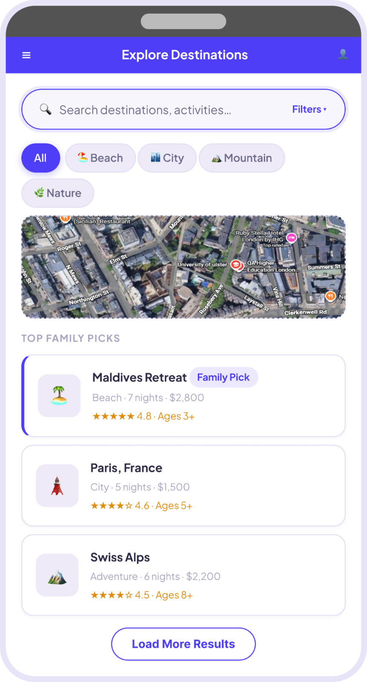

Design Rationale

Chosen Design B: 1-Up Final – Hybrid List + Embedded Map with Category Pills

The team decided "B (Map-Centric View)" represented the best solution as it removed the procedural drawbacks of option C (AI Questionnaire Flow). The winning design features a very large search field at the top of the page, category pill filters (Beach City Mountain, Nature) arranged in a row in the center of the page, a scrollable list of 'Top Family Picks' cards shown below them. The cards include the thumbnail, the destination name, the destination type, the trip price, the star rating, and an age-suitability badge (e.g. "Ages 3+"). A purple "Load More Results" button at the bottom is a call to action for users to keep searching.

Option A was dismissed on the basis that in its form of a full-screen list without a map, it did not help a user with spatial orientation. Family travellers planning road trips or destinations by proximity, need to see geographic awareness of the locations. We entirely dismissed option C as a required questionnaire prior to showing results is a major obstacle for new users. Operating with mobile, users expect instant visuals and not a multi-step wizard. Research on mobile UX shows that if forms are put in front of content, people become more inclined to leave.

Primary color of indigo/violet (#4F46E5) in the design relates to conveying trust and modernity which aligns with the Family Travel Companion brand. Age-suitability badges use amber/teal for quick recognition. The Filters button is thumb-friendly near the search bar, while the integrated map reduces effort by displaying location details without leaving the screen.

Feature 2 – Book Accommodations, Transport & Activities
Assigned to: Habibur Rahman (B01009639) | User Story: S4 – Book accommodations, transport & activities

3-Up wireframe concept

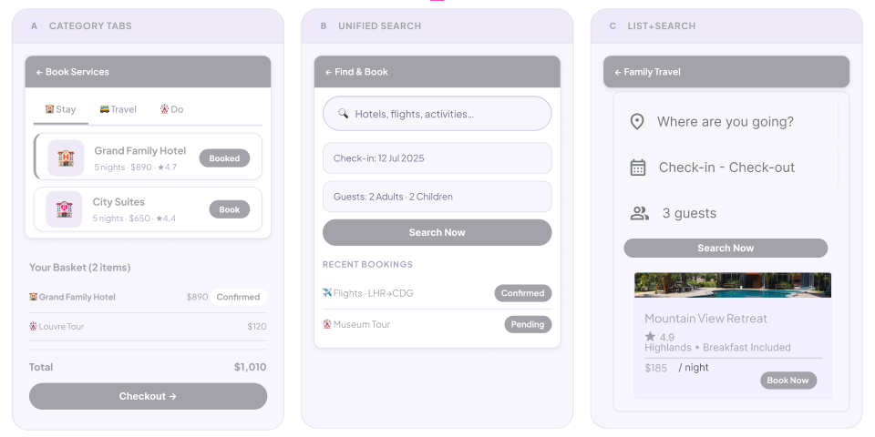

1-Up Fina design

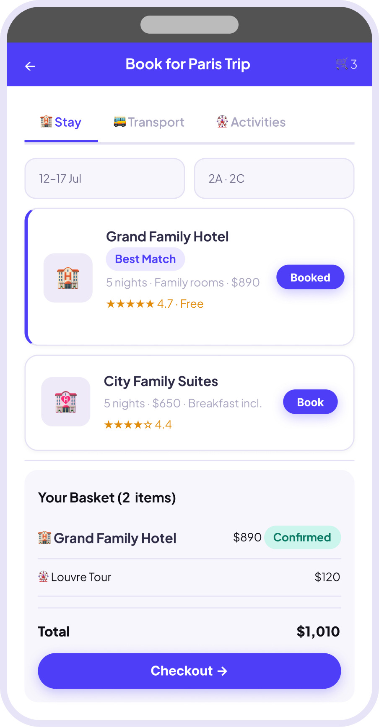

Design Rationale

Chosen Design A: 1-Up Final – Tabbed Browse with Persistent Basket Summary

Following three wireframe designs, it was evident that Design A was the most practical solution for the booking elements in terms of ease of navigation. The separation of the three service categories into three browse contexts - Stay, Transport and Activities - provides easy readability for browsing users, as they are not required to view a separate list of results for each browse. Service content for each tab is displayed as individual card views comprising of a thumbnail image name contextual indicator.

best match, family rooms, breakfast included) price a star rating and an attractive 'Book' call to action button. A sticky basket panel always remains fixed to the bottom of the page, dynamically aggregating the number of items, individual line items, subtotal and a full width 'Check out ' call to action. Date and guest fields are accessible at the top of the tab view, providing consistent booking context throughout.

Design B (Unified Search) was rejected because simultaneously searching across hotels, flights, and activities generates cognitively overloaded results. Families typically book in a natural sequence accommodation first, then transport, then activities and the tabbed structure mirrors this behaviour. Design C presented a well-considered basket concept but provided no browsing interface, rendering it incomplete as a standalone solution.

The 'Best Match' badge uses indigo to signal algorithmic recommendation without overwhelming other listing content. "Add" and "Book" buttons take on the brand indigo fill, so the interactive points of the user interface are easily identified. The 'Checkout' button, occupying the whole width of the basket panel at the bottom, is conveniently reachable with a thumb on mobile devices and serves as a visually distinct call-to-action geared towards conversion.

Feature 3 – Upload and Organise Travel Documents
Assigned to: MD Ali Hasan Jidan (B01011849) | User Story: S6 – Upload travel documents

3-Up wireframe concept
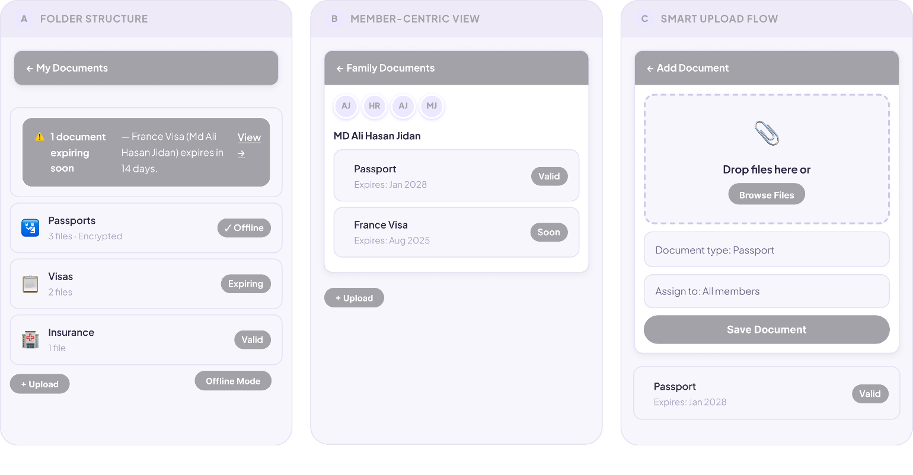

1-Up Fina design
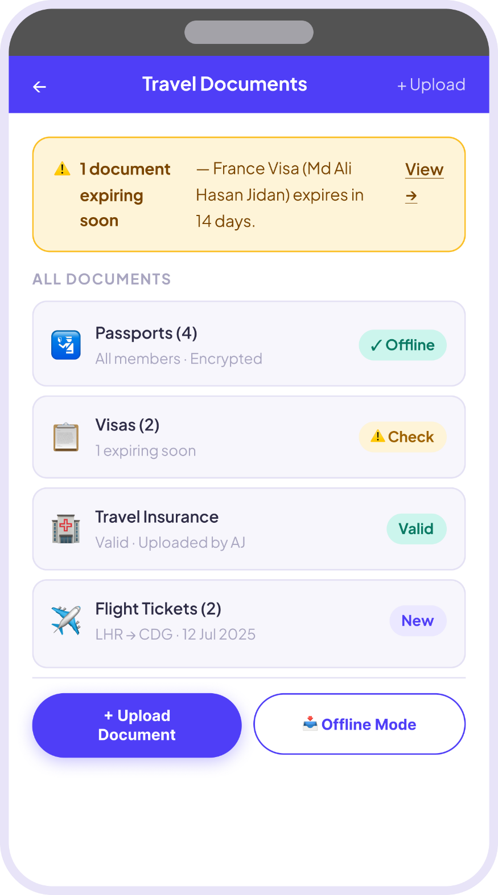

Design Rationale

Chosen Design: 1-Up Final – Folder View with Expiry Alerts and Offline Access
The selected design Option A arranges the travel documents in a folder-layout list where each folder represents a document type such as Passports Visas Travel Insurance, and Flight Tickets. Besides a document type icon, each folder row also displays the number of files included and the members having access to the documents, as well as a status badge: 'Offline' (green), 'Check' (amber warning), 'Valid' (green), or 'New' (blue)." A prominent amber alert banner at the top of the screen warns about the most urgently expiring document: 'France Visa (Md Ali Hasan Jidan) expires in 14 days View'. Two action buttons at the bottom allow the user to '+ Upload Document' (filled primary) or enter 'Offline Mode' (outlined with cloud icon).
Option B (Member-Centric View) was rejected because organising documents by family member rather than document type creates unnecessary duplication a shared travel insurance policy appears under multiple members. The document-type folder model reflects how government border controls and travel agents think about paperwork, making it more intuitive for users. Users are more likely to want a view or check their existing documents than upload new ones; therefore, Option C (Smart Upload Flow) was rejected as the landing view.
The amber warning banner, offline mode toggle, and folder metaphor first and foremost keep users informed of important messages, provide access to documents even when offline, and give a familiar structure for organizers of international travel documents through families.

Feature 4 – Manage and Track Trip Budgets
Assigned to: Md Jahirul Islam (B00999362) | User Story: S5 – Manage trip budgets

3-Up wireframe concept
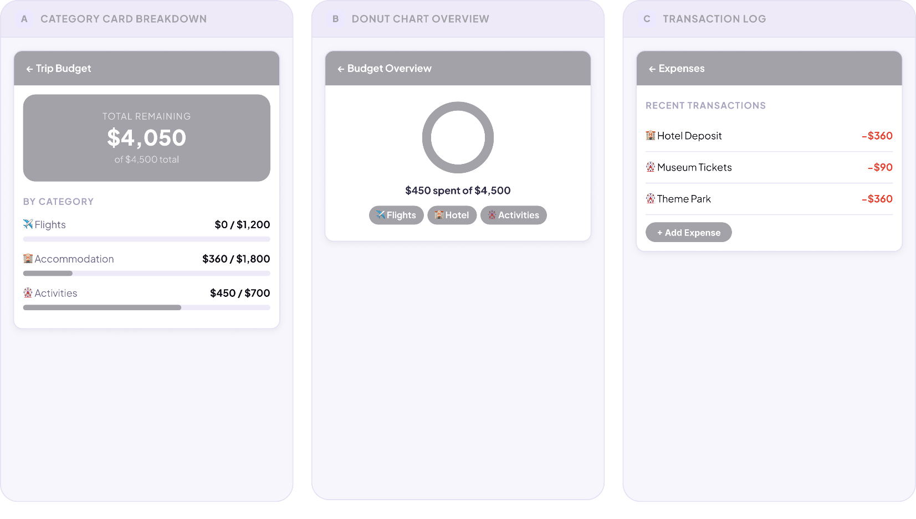

1-Up Fina design

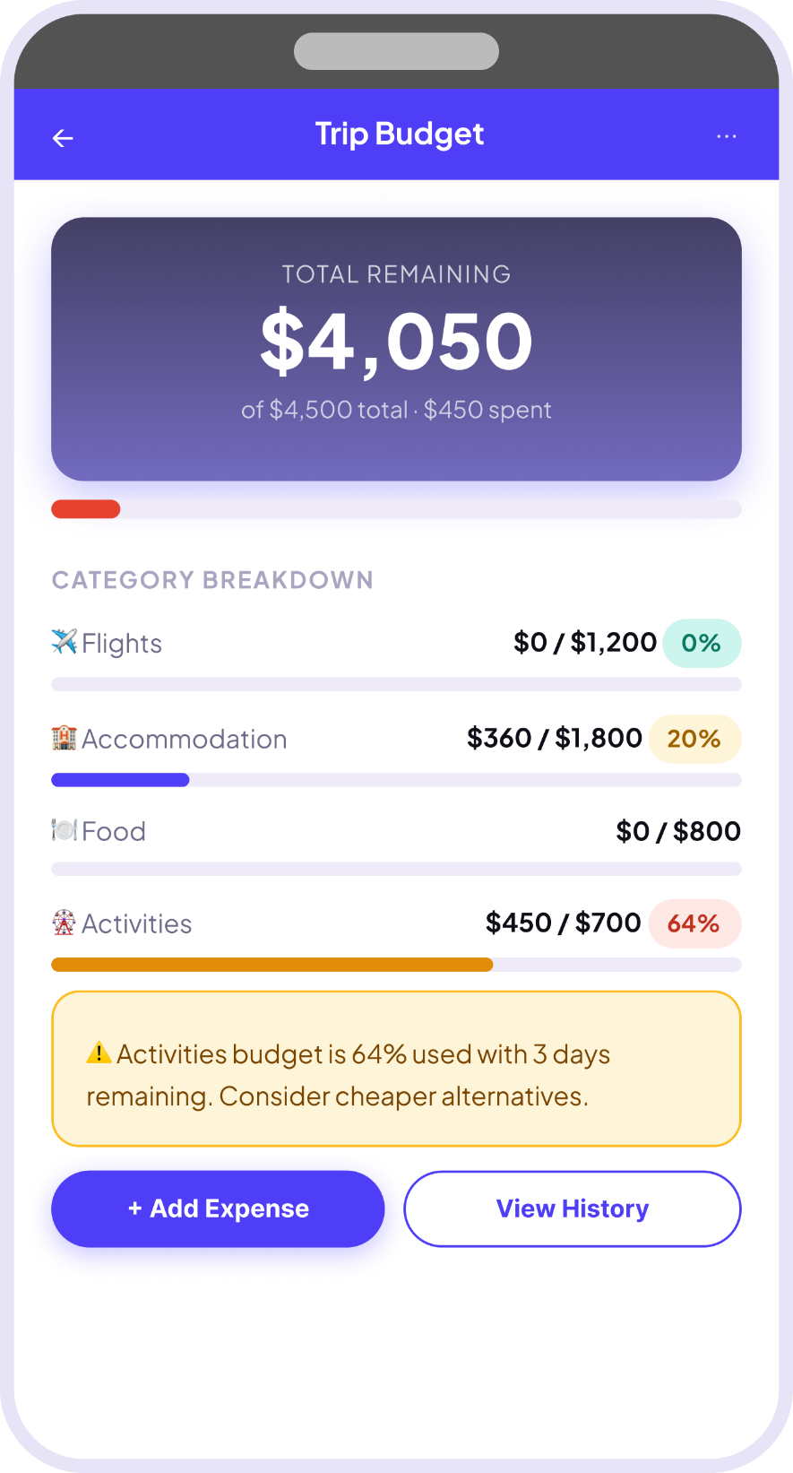

Design Rationale

Chosen Design A: 1-Up Final – Budget Dashboard with Category Progress Bars
The chosen design proposes a 'Trip Budget' dashboard featuring a full-width hero card that showcases the total remaining balance very clearly ($4,050 out of $4,500 total). Under this, each spending category (Flights Accommodation Food, Activities) is represented as a row with a label, spent/total ratio, a figure in percentage used, and a color-coded horizontal progress bar. An amber warning panel automatically shows up if a budget category gets to a high usage level (e.g. 'Activities budget is 64% used with 3 days remaining').
Option B (Donut Chart Overview) is turned down because although a donut chart is visually appealing, it makes users to look for a legend to find out the amounts of each category. For a multi-category travel budget with four or more-line items, granular progress bars are demonstrably easier to scan. Option C (Transaction Log) is rejected as the primary view because showing raw transactions first imposes unnecessary cognitive load users care about 'how much is left' more than a chronological receipt list. The transaction log is better suited as a secondary screen accessed via 'View History'.
The hero card uses a deep indigo gradient to create visual hierarchy and ensure the most important data point remaining balance is unmissable. Progress bars use yellow-amber for moderate usage and would shift to red for critical levels, providing clear pre-attentive visual cues. The '+ Add Expense' button is filled (primary) while 'View History' is outlined (secondary), establishing a clear action hierarchy. The warning panel uses amber to maintain non-alarming but noticeable feedback, avoiding red which might cause user anxiety over normal spending.

Feature 5 – Coordinate Group Trips and Schedules
Assigned to: Komalpreet Kaur (B01015647) | User Story: S15 – Coordinate group trips

3-Up wireframe concept

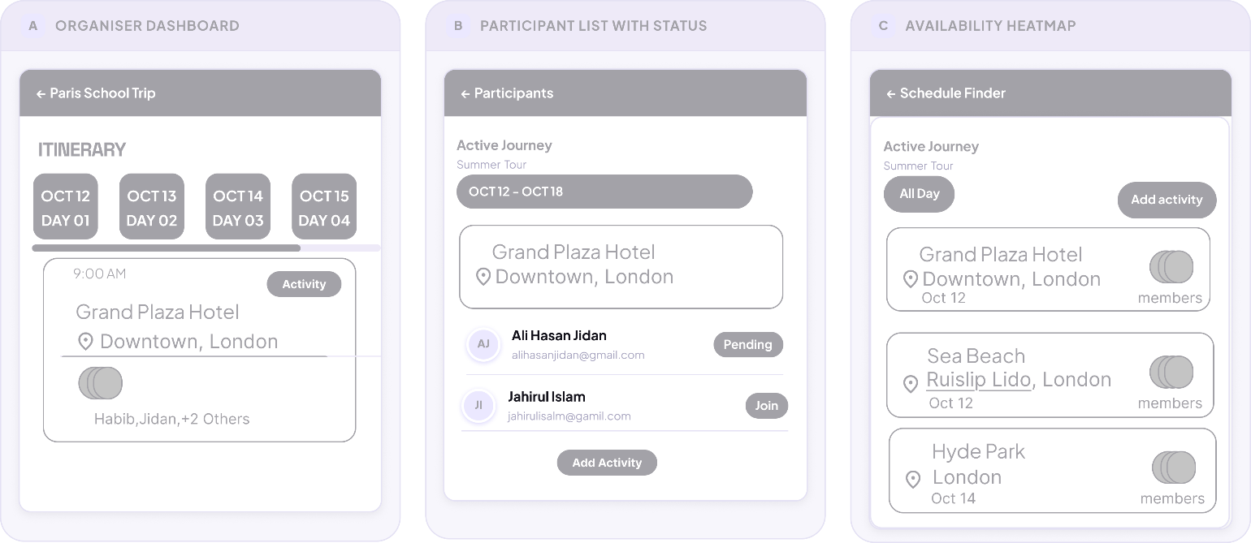

1-Up Fina design

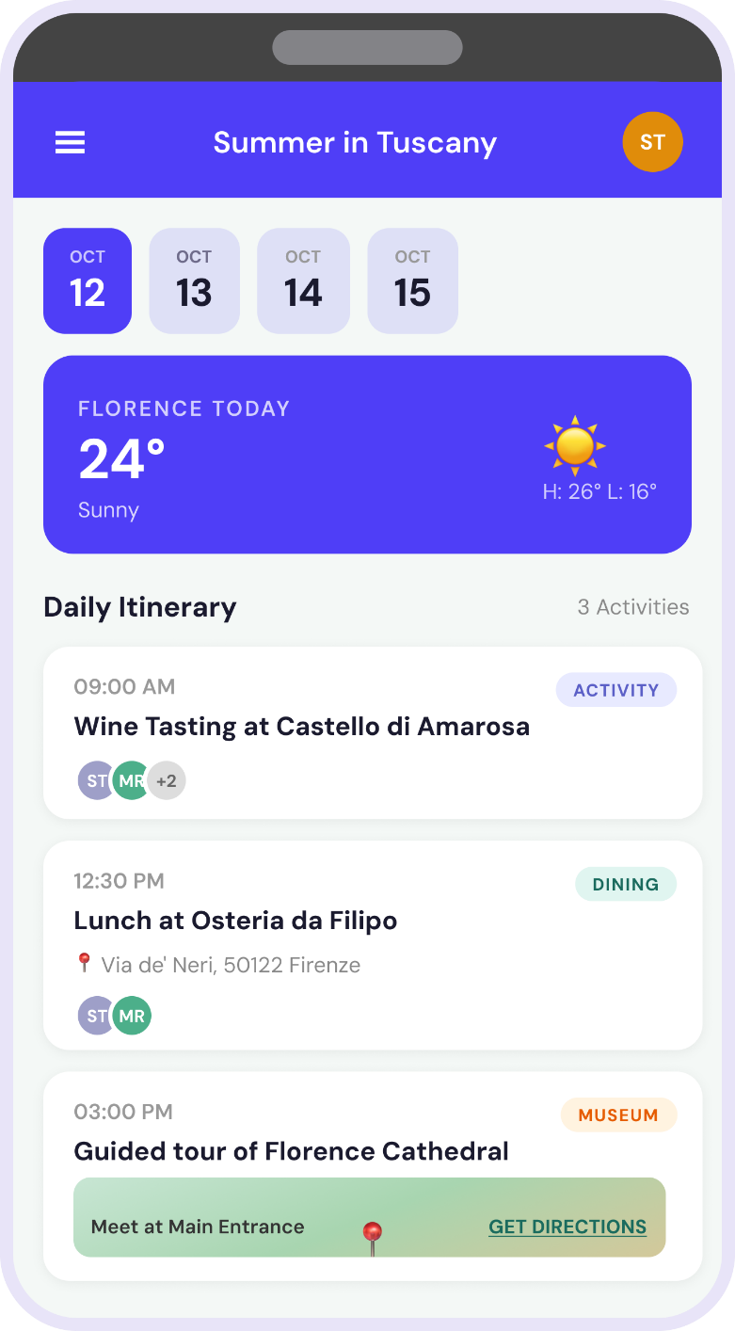

Design Rationale

Chosen Design A: 1-Up Final – Organiser Dashboard
Chosen Design: A – Organiser Dashboard (Itinerary‑first view)

Design A was selected as it truly addresses the main issue of group vacation arrangement: sorting out "What's going on now?" and "Who is coming?" without adding mess. The interface is centered on a daily itinerary timeline, with day tabs (OCT12-OCT15) and time-attached activity blocks (e.g. 9:00 AM). Each block contains the venue name, address, a confirmation badge , and inline attendee names Habib, Jidan, +2 Others making occupancy and participation immediately visible.

This layout eliminates the need for secondary pop‑ups or cross‑referencing. An organiser can scan down the timeline and instantly see who is present or missing from any activity. The use of “+X Others” compresses groups without hiding essential information.

Why not B or C?
Design B (Participant list with status) presents 35+ names in a flat list. To understand who is joining a specific activity, the organiser would have to manually match each name against the itinerary slow and impractical for real‑time coordination. Design C (Availability heatmap) appears data‑rich, but colour gradients become unreadable beyond 15–20 participants, and the map abstracts away venue details and guest counts. Both were rejected for lacking temporal and locational clarity.

Colour and typography stay neutral, with mild green for confirmation badges and soft grey for attendee names. The vertical rhythm (date-time-venue-people) follows a natural reading order. By prioritising the itinerary timeline, Design A reduces cognitive load and enables the organiser to spot conflicts or low attendance in under two seconds exactly what a busy trip leader need.

Feature 6 – Create and Edit Shared Trip Itineraries
Assigned to: Sheheryar Khan (B01010078) | User Story: S2 – Create & edit shared itineraries

3-Up wireframe concept
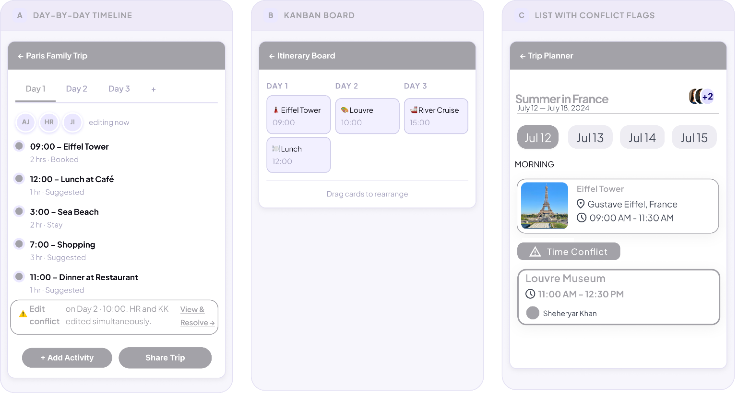

1-Up Fina design

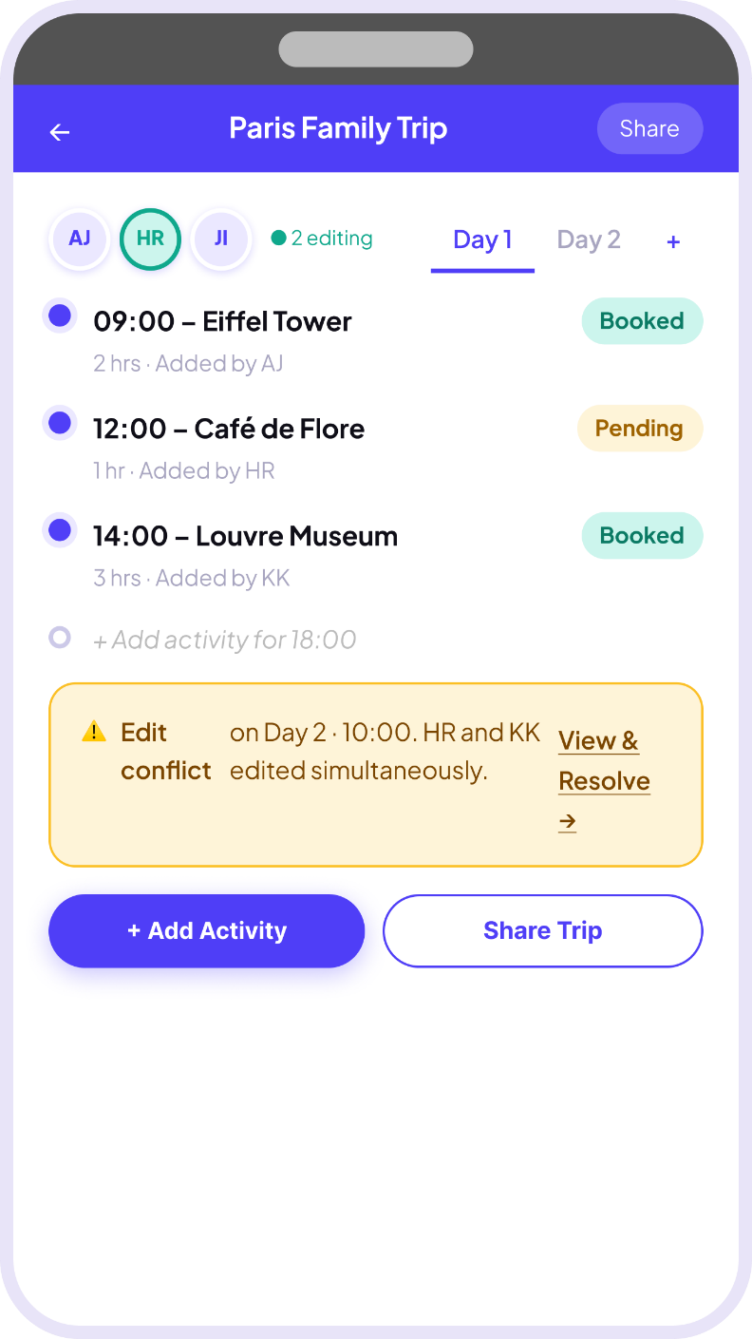

Design Rationale

Chosen Design A: 1-Up Final – Collaborative Timeline with Live Presence
The final design uses a sequential day-by-day timeline as main structure, supported by live collaborative presence indicators (avatar initials: AJ, HR, JI) and real-time conflict detection. Each activity is represented by a time-anchored card with details like time, activity name duration who added it, and a booking status tag (Booked / Pending). When simultaneous edits cause schedule clash, a permanent amber conflict warning shows at the bottom of screen with the 'View & Resolve' link.
Option B (Kanban Board) is rejected because a drag-and-drop column model is poorly suited to a mobile-first app. On small devices, Kanban boards undoubtedly need a lot of horizontal scrolling, and they are not properly able to show time relationships as well as a linear timeline can. For instance, representing a trip to Paris with events at 9:00, 12:00, and 14:00 is much more intuitively done via a vertical list than a Kanban card stack. Option C (List with Conflict Flags) gets high marks for its conflict detection user interface but it does not have the timeline's temporal clarity and collaborative presence feature.

The color coding used in this feature is deliberate: 'Booked' statuses use green to signal success, 'Pending' uses orange-amber as a caution indicator, consistent with universal traffic-light conventions. The 'Add Activity' and 'Share Trip' buttons are placed at the bottom of the screen within thumb reach on a smartphone using a split-button layout that makes the two most common actions equally prominent. Avatar bubbles at the top communicate real-time collaboration clearly, borrowing familiarity from tools like Google Docs.

Feature 7 – Redeem Points for Rewards
Assigned to: Syed Abdul Hafeez (B01012379) | User Story: S28 – Redeem points for rewards

3-Up wireframe concept
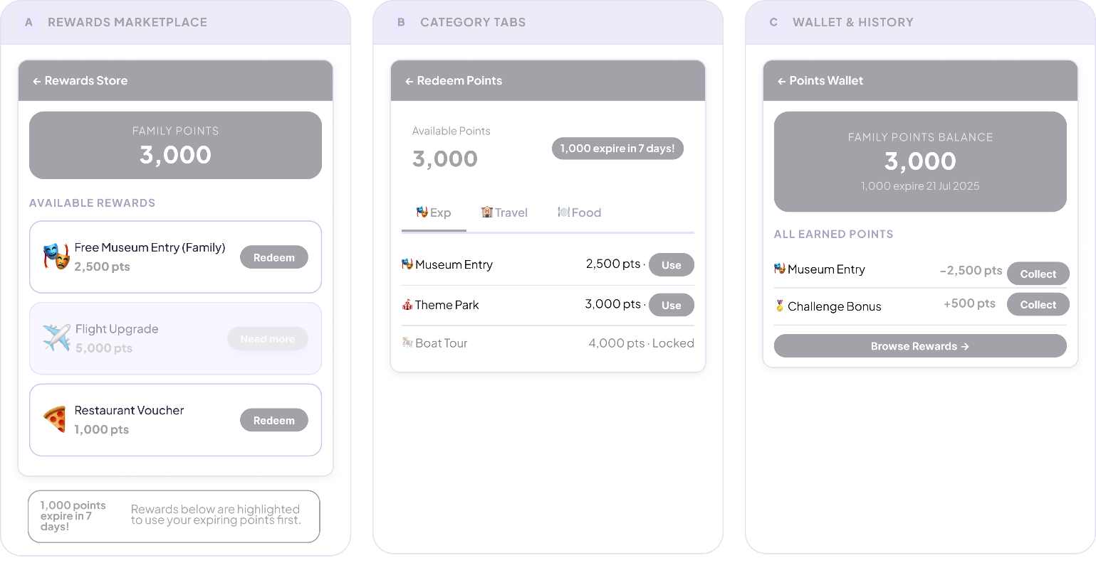

1-Up Fina design

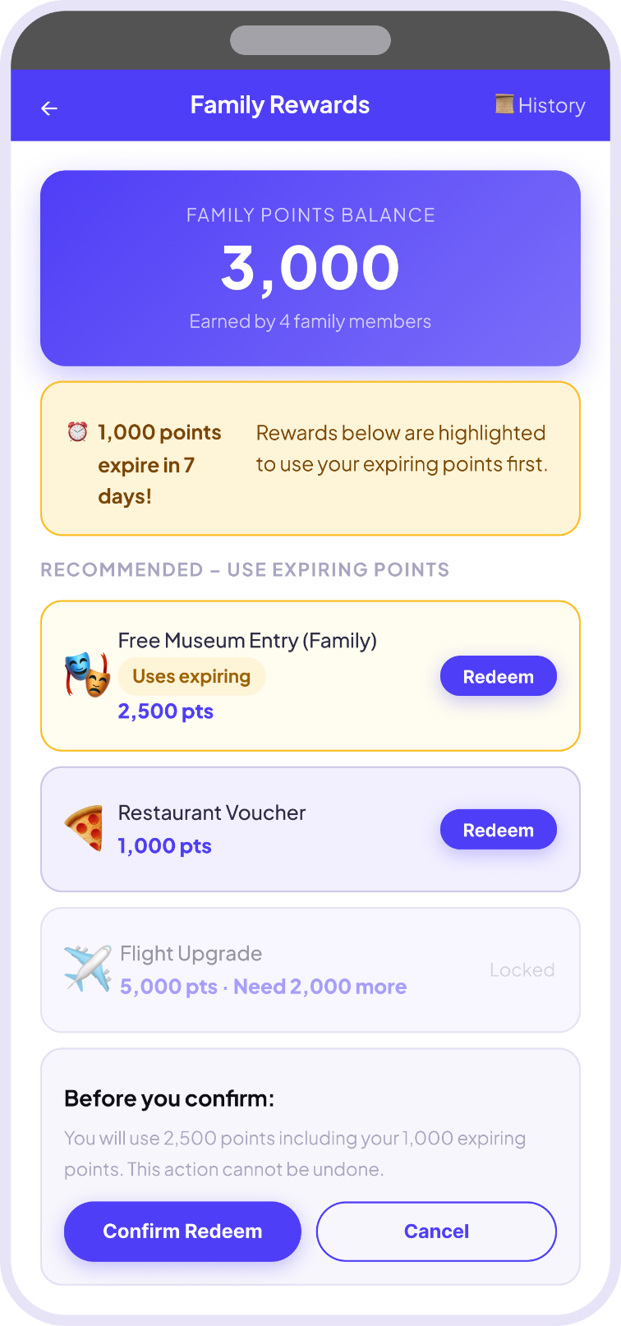

Design Rationale

Chosen Design A: 1-Up Final – Rewards Store with Expiry Alerts & Confirmation
The Rewards feature final design opens with a Family Rewards screen displaying a full-width indigo hero card showing the total family balance of 3,000 pts, with a subtitle confirming this was earned by four family members. Below it, an amber expiry alert notifies users that 1,000 points expire in seven days, and the rewards list automatically pre-filters to surface redeemable items using those expiring points first. Each reward card shows an icon, a name, and a point cost along with the contextual labels: amber "Uses Expiring, " greyed "Locked, " or normal redeemable. Right before any redemption is finalized, a confirmation panel inside the line of the points transaction pops up, tells the user that the action is irreversible and shows the unattractive "Cancel" (outlined) and the very attractive "Confirm Redeem" (filled) buttons.
Option A choose because, provides a simple and familiar marketplace experience that allows users to view all rewards in one place, making browsing and comparison easy and intuitive without additional navigation complexity. Option B's category tabs add navigational overhead and bury the expiry signal behind agnostic headers. Option C's wallet-history view deprioritises action in favour of records secondary to current need.
The indigo hero card reinforces brand identity while making balances salient; gamification research confirms visible balances drive engagement. Amber is chosen deliberately psychologically signalling time pressure without red's negativity. The locked Flight Upgrade card, labelled "Need 2,000 more," converts inaccessibility into aspiration. The irreversibility confirmation panel reduces redemption errors, especially critical in shared family sessions where multiple members may act simultaneously. Every design decision prioritises clarity, urgency, and confidence.
6. Development Tasks
- Story ID: S1 – Search for Family-Friendly Destinations

Task ID: T1 | Task Title: Design and Implement Destination Database Schema
Task Size | Large
Dependencies | None
Subtasks | Define a relational database schema (e.g. PostgreSQL) with a Destinations (pgSQL table, with columns: destination_id (pk) name country region, category (beach/city/mountain/nature) description average_price_per_night, age_suitability_min star_rating thumbnail_url, and latitude/longitude.
 | Create a DestinationTags junction table to support many-to-many relationships between destinations and family-friendly tags (e. g. child-friendly, wheelchair accessible).
 | Make sure that all the columns have the data types, the NOT NULL constraints and default values for the columns where needed.
 | [Spread index] apply an index to the most often searched for columns category star_rating and average_price_per_night.
 | Ensure the Third Normal Form (3NF) is attained in all the tables.
 | To evaluate the system, populate the database with a minimum of 20 family-friendly destinations.
 | And the ER diagram documented in the project wiki.

Task ID: T2 | Task Title: Build Destination Search API Endpoint
Task Size | Large
Dependencies | T1
Subtasks | Develop a RESTful GET /api/destinations/search API endpoint in Node. js/Express (or ASP. NET Core) that take keyword category min_price max_price min_age, min_rating query parameters.
 | Use ILIKE (PostgreSQL) or a full-text index to do full text search on destination name and description fields.
 | Apply server-side filtering logic for category pills (All, Beach, City, Mountain, Nature).
 | Sort the result by star rating and recent booking trends (booking_count DESC).
 | Give paginated JSON responses via the limit/offset mechanism (default 10 results per page).
 | Add a caching layer (Redis or in-memory) to temporarily store cached popular results for fallback when the external API is unavailable, as required by the acceptance criteria.
 | If the external recommendation API is not available, return a structured error response with HTTP 503 and a message explaining the situation.

Task ID: T3 | Task Title: Implement Interactive Map Component
Task Size | Medium
Dependencies | T1, T2
Subtasks | Embed a mapping library like Mapbox GL JS or Google Maps JavaScript API into the React/Vue frontend.
 | Put destination points on the map according to the latitude and longitude info gotten from the search API.
 | Use a marker grouping technique to avoid clutter when there are lot of points in a geographical area.
 | Link the map view to the destination list: a mouse click on a list card moves the map; a mouse click on a map marker shows the corresponding list card.
 | Make the map responsive to different screen sizes of mobile and desktop by using CSS media queries.
 | Introduce an 'Explore on Map' switch that alters between map-centric and list-centric layouts.
 | Make sure that map tiles are loaded over HTTPS and that user privacy is respected (no user analytics tracking without consent).

Task ID: T4 | Task Title: Build Destination Search UI with Category Pills and Result Cards
Task Size | Medium
Dependencies | T2, T3
Subtasks | Build the 'Explore Destinations' screen per the approved 1-Up wireframe (Design B – Hybrid List + Embedded Map).
 | Implement category pill filter buttons (All, Beach, City, Mountain, Nature) that update search results on click without a full page reload.
 | Render each destination as a card component displaying: thumbnail image, destination name, type, trip price, star rating, and an age-suitability badge (e.g., Ages 3+).
 | Add a 'Top Family Picks' section that surfaces algorithmically recommended results with a highlighted border.
 | Implement the 'Load More Results' button using infinite scroll or explicit pagination.
 | Apply the brand indigo/violet (#4F46E5) primary colour to pill filters and CTA buttons.
 | Ensure WCAG 2.1 AA colour contrast compliance on all text elements.

Task ID: T5 | Task Title: Implement Offline Fallback and Error Handling for Search
Task Size | Medium
Dependencies | T2, T4
Subtasks | Implement a service worker (Workbox or custom) that caches popular destination data on first load for offline access.
 | Display a banner notification: 'Showing recent popular results. Full search functionality will be available shortly.' when the external API is unavailable.
 | Provide a visible Retry button that re-triggers the search request once the user taps/clicks it.
 | Show a 'No matches found. Try relaxing one or more filters.' message with one-click filter-reset suggestions when no results are returned.
 | Display at least three alternative popular family-friendly destinations as quick suggestions alongside the no-results message.
 | Write unit tests covering: empty result handling, API timeout fallback, and retry logic.
 | Log all API errors to the application monitoring service (e.g., Sentry) for observability.

Task ID: T6 | Task Title: Integrate External Recommendation API and Write Integration Tests
Task Size | Large
Dependencies | T1, T2, T5
Subtasks | Integrate a third-party travel recommendations API (e.g., Amadeus Travel API or TripAdvisor Content API) using an adapter pattern to decouple the external dependency.
 | Map external API response fields to the internal Destination schema for consistency.
 | Implement API key management using environment variables (.env) and ensure keys are never committed to version control.
 | Configure a circuit-breaker pattern (e.g., using opossum library) to gracefully degrade to cached results when the external API fails repeatedly.
 | Write integration tests using Jest/Supertest covering: successful search, category filter, pagination, external API failure, and offline fallback scenarios.
 | Document the integration in the project API reference, including request/response examples and error codes.
 | Conduct a performance test to verify that search results are returned within 2 seconds under normal load conditions.

- User Story S4 – Book Accommodations, Transport & Activities

Task ID: T7 | Task Title: Design Booking and Basket Database Schema
Task Size | Large
Dependencies | T1
Subtasks | Define a Bookings table with columns: booking_id (PK), trip_id (FK), user_id (FK), booking_type ENUM('stay','transport','activity'), service_id, quantity, unit_price, total_price, status ENUM('pending','confirmed','cancelled'), booking_date, and check_in/check_out dates.
 | Define a Basket table to hold transient booking items before checkout: basket_id (PK), session_id, user_id (FK), service_id, service_type, price, added_at timestamp.
 | Define a BookingConfirmations table to store vouchers, e-tickets, and QR code references.
 | Apply foreign key constraints with CASCADE DELETE where appropriate.
 | Ensure 3NF compliance and index on trip_id, user_id, and status columns.
 | Create stored procedures or ORM migrations for basket-to-booking promotion on payment confirmation.
 | Write database migration scripts using Flyway or Liquibase for version-controlled schema changes.

Task ID: T8 | Task Title: Build Booking Browse API (Stay, Transport, Activities)
Task Size | Large
Dependencies | T7
Subtasks | Create RESTful GET /api/services/{type} endpoints where type is: stays, transport, or activities, accepting query params: destination_id, check_in, check_out, guests_adults, guests_children.
 | Integrate partner inventory APIs (e.g., Booking.com Affiliate API for stays, Amadeus Flight API for transport) using the adapter pattern.
 | Return service listing cards with: service_id, name, thumbnail, price, star_rating, labels (e.g., 'Best Match', 'Family rooms', 'Breakfast incl.'), and availability status.
 | Implement the 'Best Match' algorithm using a weighted scoring function: rating (40%), price (30%), family-suitability (30%).
 | Handle real-time availability checks with appropriate HTTP caching headers (Cache-Control: max-age=60) to reduce redundant partner API calls.
 | Return a standardised error response when a service is fully booked, including waitlist availability.
 | Write unit tests for the filtering, scoring, and error-handling logic.

Task ID: T9 | Task Title: Build Booking UI with Tabbed Browse and Persistent Basket
Task Size | Large
Dependencies | T8
Subtasks | Build the 'Book for Trip' screen per the approved 1-Up wireframe (Design A – Tabbed Browse with Persistent Basket Summary).
 | Implement three-tab components: Stay, Transport, and Activities, each fetching from the corresponding /api/services/{type} endpoint.
 | Render each service listing as a card with thumbnail, name, labels, price, star rating, and a prominent indigo 'Add' button.
 | Implement a collapsible basket panel fixed to the bottom of the screen, displaying item count, line items, running total, and a full-width 'Checkout' CTA button.
 | Update the basket panel in real-time whenever an item is added or removed, using React state or Vuex store.
 | Display a basket item count badge on the basket icon in the top navigation bar.
 | Ensure all tab content and basket panel are fully accessible using ARIA roles and keyboard navigation.

Task ID: T10 | Task Title: Implement Booking Checkout and Payment Processing
Task Size | Large
Dependencies | T7, T8, T9
Subtasks | Build a multi-step checkout flow: (1) Review basket summary, (2) Select/confirm payment method, (3) Confirm booking.
 | Integrate a payment gateway (e.g., Stripe or PayPal) using the server-side SDK; never transmit raw card data through the application server (use tokenization).
 | Implement support for family-linked payment methods: allow switching between saved family member cards at checkout.
 | On successful payment, promote basket items to confirmed bookings in the database and generate confirmation documents (hotel voucher PDF, e-ticket).
 | Store confirmation documents in the trip documents folder (linked to S6 Upload Documents feature) and send push notifications with booking references and QR codes to all family members.
 | Implement draft booking save functionality: when payment fails, save the basket as a draft with a 'Retry Payment' CTA.
 | Display clear error messages for declined cards: 'Payment could not be processed. Please update or choose another payment method.' with actionable next steps.

Task ID: T11 | Task Title: Implement Waitlist and Capacity Management
Task Size | Medium
Dependencies | T7, T8
Subtasks | Implement real-time availability tracking: when a service has fewer spots remaining than the group size, display a prominent capacity alert: 'Only X spots are available for your group size of Y.'
 | Provide alternative suggestions when full capacity is reached: query the /api/services/{type} endpoint filtered by similar rating range, price band, and location proximity.
 | Implement a waitlist mechanism: allow users to book available spots and place remaining group members on a waitlist with email/push notification on availability.
 | Create a Waitlist database table: waitlist_id (PK), booking_id (FK), user_id (FK), service_id, position, created_at, notified_at.
 | Implement a background job (worker) that monitors capacity and automatically notifies waitlisted users when spots become available.
 | Write integration tests for: full capacity scenario, partial booking with waitlist, and alternative suggestion responses.

Task ID: T12 | Task Title: Write End-to-End Tests for Booking Flow
Task Size | Medium
Dependencies | T9, T10, T11
Subtasks | Write Cypress or Playwright end-to-end tests covering the full booking flow: browse-add to basket-checkout-confirmation.
 | Test the payment failure scenario: mock a declined card response and verify the error message, draft save, and retry options are displayed correctly.
 | Test the insufficient capacity scenario: mock a service with fewer spots than group size and verify the alert and alternative suggestions appear.
 | Test that confirmation documents appear in the trip documents folder after successful booking.
 | Test basket persistence across tab switches (Stay-Transport-Activities) to ensure items are not lost on navigation.
 | Integrate tests into the CI/CD pipeline (GitHub Actions or GitLab CI) to run on every pull request.
 | Generate and archive test reports as build artefacts for stakeholder review.

7. Test Cases
We have made thirty test cases (three for each user story) for ten user stories from the Family Travel Companion story map. Test cases are set up to match the acceptance criteria set in Part 1. This makes sure that everything can be traced back from the user's need to verification. The ten user stories that were chosen are S1, S2, S4, S5, S6, S15, S16, S21, S27, and S28.
Team test case:
- User Story S1 – Search for Family-Friendly Destinations
Test Case ID: Test Case ID: TC1
Test Description: Search with keyword only returns popular family-friendly results
User Story  ID: S1 | User Story Title: Search for Family-Friendly Destinations
Step ID | Step Description | Test Data | Expected Result
1 | Navigate to the Explore Destinations page. |  | The Explore Destinations page has a search bar, category pills (All, Beach, City, Mountain, Nature), an embedded map, and a section called "Top Family Picks."
2 | Type 'fun family holiday' into the search bar and press Search. | fun family holiday | The results list populates with popular family-friendly destinations worldwide, sorted by star rating and booking trends. Filter refinement options are displayed at the top.
3 | Verify result cards contain required attributes. |  | Each destination card displays a thumbnail, destination name, type, trip price, star rating, and age-suitability badge (e.g., Ages 3+).

Test Case ID: TC2
Test Description: Overly restrictive filters return no results with helpful suggestions
User Story ID: S1 | User Story Title: Search for Family-Friendly Destinations
Step ID | Step Description | Test Data | Expected Result
1 | Open Explore Destinations and apply filters: budget $0 – $100, luxury 5-star only, remote islands only. | Budget: $0 – $100,  Rating: 5*  Category: Remote Island | Filter pills update to reflect selections. The embedded map clears markers from non-matching destinations.
2 | Click the Search button. |  | The message 'No matches found. Try relaxing one or more filters.' is displayed prominently.
3 | Observe the suggestions provided below the no-results message. |  | At least three popular alternative family-friendly destinations are displayed as quick-access cards, each with a one-click option to relax the most restrictive filter.

Test Case ID: TC3
Test Description: Search returns cached results when external API is unavailable
User Story ID: S1 | User Story Title: Search for Family-Friendly Destinations
Step ID | Step Description | Test Data | Expected Result
1 | Simulate external recommendation API unavailability (disable API endpoint in test environment). | API status: 503 Service Unavailable | The system does not display an unhandled error page.
2 | Submit a search for 'beach destinations'. | beach destinations | The system immediately displays cached popular family destinations with a banner: 'Showing recent popular results. Full search functionality will be available shortly.'
3 | Click the Retry button displayed on the banner. |  | The application re-attempts the API call. If the service remains unavailable, the cached results persist and the banner remains. If the service recovers, full search results are loaded and the banner disappears.

- User Story S2 – Create and Edit Shared Trip Itineraries

Test Case ID: TC4
Test Description: Real-time collaborative editing by family members on different days
User Story ID: S2 | User Story Title: Create and Edit Shared Trip Itineraries
Step ID | Step Description | Test Data | Expected Result
1 | User A (trip owner) creates a Paris Family Trip itinerary and invites User B. Both users open the itinerary simultaneously. | Trip: Paris Family Trip; Users: A (AJ), B (HR) | Both users can see the itinerary. The presence bar displays avatar initials AJ and HR with the indicator '2 editing'.
2 | User A adds activity '09:00 – Eiffel Tower' on Day 1. User B simultaneously adds '12:00 – Café de Flore' on Day 1. | A: Eiffel Tower 09:00; B: Café de Flore 12:00 | Both changes are reflected on both screens within 2 seconds. No data is overwritten. User A sees Café de Flore appear; User B sees Eiffel Tower appear.
3 | User B views the updated Day 1 timeline. |  | The Day 1 timeline shows both activities in chronological order: 09:00 Eiffel Tower (Added by AJ, status: Booked) and 12:00 Café de Flore (Added by HR, status: Pending).

Test Case ID: TC5
Test Description: Conflict resolution when two users edit the same activity slot simultaneously
User Story ID: S2 | User Story Title: Create and Edit Shared Trip Itineraries
Step ID | Step Description | Test Data | Expected Result
1 | User A and User B both open the same activity slot '14:00 – Louvre Museum' on Day 2 for editing simultaneously. | Activity: Louvre Museum, Day 2, 14:00 | Both users see the edit form open for the same slot. An amber conflict indicator appears in the corner of the edit panel for both users.
2 | User A changes the time to 15:00 and saves. User B changes the activity name to 'Louvre & Gift Shop' and also saves. | A: time = 15:00,  B: name = Louvre & Gift Shop | A merge conflict dialog appears for both users, showing both versions side by side: Version A (time: 15:00) and Version B (name: Louvre & Gift Shop).
3 | User A selects 'Merge both changes' from the conflict dialog. |  | The activity is saved as: name = 'Louvre & Gift Shop', time = 15:00. The conflict indicator disappears and both users' screens update immediately.

Test Case ID: TC6
Test Description: Edit permission revoked mid-session prevents further saving
User Story ID: S2 | User Story Title: Create and Edit Shared Trip Itineraries
Step ID | Step Description | Test Data | Expected Result
1 | User B is actively editing Day 3 of the itinerary with edit permissions granted. | User B has edit role on trip | User B can see and interact with all edit controls on the itinerary.
2 | User A (trip owner) navigates to Manage Permissions and revokes User B's edit access. | Action: revoke edit permission for User B | User A sees a confirmation message: 'Edit rights revoked for HR.' User A's view is unchanged.
3 | User B attempts to save a change they were composing before the revocation. | B attempts to save: activity 'Day trip to Versailles, 10:00' | The save action fails. User B's interface switches to read-only mode. A message appears: 'Edit rights have been revoked. You can now view the itinerary only.' The unsaved change is discarded.

- User Story S4 – Book Accommodations, Transport & Activities

Test Case ID: TC7
Test Description: Successful end-to-end family booking with confirmation documents
User Story ID: S4 | User Story Title: Book Accommodations, Transport & Activities
Step ID | Step Description | Test Data | Expected Result
1 | Navigate to 'Book for Paris Trip'. Select the 'Stay' tab. Choose 'Grand Family Hotel' (5 nights, $890) and click Add. | Hotel: Grand Family Hotel, 5 nights, $890, 12–17 Jul, 2A·2C | The basket panel at the bottom updates to show 'Grand Family Hotel $890'. The basket item count badge changes to 1.
2 | Switch to the 'Transport' tab. Select 'Flights LHR-CDG' ($420) and click Add. | Flight: LHR-CDG, $420 | The basket panel shows 2 items. Running total updates to $1,310. Both items are visible in the basket.
3 | Click 'Checkout', review the summary, confirm payment using the family-linked card, and click 'Confirm Redeem'. | Payment: family Visa card ending | Booking is confirmed. Confirmation documents (hotel voucher PDF and e-ticket) appear in the Trip Documents folder. All family members receive a push notification containing the booking reference and QR codes. Total charged: $1,310.

Test Case ID: TC8
Test Description: Booking failure due to declined payment card
User Story ID: S4 | User Story Title: Book Accommodations, Transport & Activities
Step ID | Step Description | Test Data | Expected Result
1 | Add 'Grand Family Hotel' and 'Flights LHR-CDG' to the basket and proceed to checkout. | Basket total: $1,310 | Checkout summary screen is displayed with a 'Confirm & Pay' button.
2 | Enter an expired payment card and click 'Confirm & Pay'. | Card: 4000 0000 0000 0002 (Stripe declined test card), Exp: 01/22 | The payment is declined. An error message displays: 'Payment could not be processed. Please update or choose another payment method.'
3 | Observe the recovery options presented. |  | Three options are visible: (1) Update payment details, (2) Switch to another family member's saved payment method, (3) Save booking as a draft to retry later. No booking is created in the database.

Test Case ID: TC9
Test Description: Booking blocked due to insufficient activity capacity for group size
User Story ID: S4 | User Story Title: Book Accommodations, Transport & Activities
Step ID | Step Description | Test Data | Expected Result
1 | Navigate to the Activities tab. Search for 'Louvre Guided Family Tour' (capacity: 4 remaining). The family group size is 6. | Activity: Louvre Guided Tour,  remaining capacity: 4, group size: 6 | The activity card shows '4 spots remaining' in amber text beside the Add button.
2 | Click 'Add' for the Louvre Guided Family Tour. |  | A prominent alert appears: 'Only 4 spots are available for your group size of 6.' The item is not added to the basket automatically.
3 | Review options presented to the user. |  | Three options are displayed: (1) Book 4 available spots and place remaining 2 on the waitlist, (2) View alternative activities with similar ratings and price range, (3) Cancel. Alternative activities are listed immediately below the alert.

- User Story S5 – Manage and Track Trip Budgets

Test Case ID: TC10
Test Description: Real-time budget dashboard updates when a new expense is recorded
User Story ID: S5 | User Story Title: Manage and Track Trip Budgets
Step ID | Step Description | Test Data | Expected Result
1 | Navigate to the Trip Budget screen. A total budget of $4,500 has been set with category allocations: Flights $1,200, Accommodation $1,800, Food $800, Activities $700. | Total budget: $4,500; Activities spent: $0/$700 | The hero card displays 'TOTAL REMAINING $4,500 of $4,500 total · $0 spent'. Each category progress bar shows 0%.
2 | Tap 'Add Expense', select category 'Activities', and enter $450. | Category: Activities, Amount: $450 | The expense form accepts the entry. A submission confirmation is shown.
3 | Return to the Trip Budget dashboard. |  | Hero card updates to '$4,050 of $4,500 total · $450 spent'. The Activities row updates to '$450/$700 · 64%' with an amber progress bar. An amber warning panel appears: 'Activities budget is 64% used with 3 days remaining. Consider cheaper alternatives.' All family members with access to the trip see the updated figures.

Test Case ID: TC11
Test Description: Over-budget warning displayed when expense exceeds remaining budget
User Story ID: S5 | User Story Title: Manage and Track Trip Budgets
Step ID | Step Description | Test Data | Expected Result
1 | Set remaining budget to $200 by recording previous expenses totalling $4,300 against a $4,500 budget. | Remaining budget: $200 | Hero card shows '$200 remaining'. All category bars are at or near 100%.
2 | Tap 'Add Expense' and attempt to add an optional activity expense of $350. | Category: Activities, Amount: $350 | A prominent warning notification appears immediately: 'This expense will exceed the remaining budget by $150. Would you like to proceed or explore cheaper alternatives?'
3 | Review the options presented and select 'View cheaper alternatives'. |  | The system displays suggested lower-cost alternative activities. The transaction is not recorded until the user makes a final decision. If the user proceeds, the over-budget expense is saved and flagged in the budget history. If cancelled, no record is created.

Test Case ID: TC12
Test Description: Invalid expense amount is rejected with inline validation error
User Story ID: S5 | User Story Title: Manage and Track Trip Budgets
Step ID | Step Description | Test Data | Expected Result
1 | Tap 'Add Expense' and leave the amount field empty, then tap Submit. | Amount: (empty) | An inline validation error appears: 'Expense amount must be a positive value.' The Submit button is disabled. The input field is highlighted in red.
2 | Enter a negative value (-100) in the amount field and tap Submit. | Amount: -100 | The same inline validation error appears. The expense is not saved. The input field remains highlighted.
3 | Enter 0 (zero) in the amount field and tap Submit. | Amount: 0 | Validation error persists: 'Expense amount must be a positive value.' The form cannot be submitted until a valid positive number is entered. No record is created in the database.

- User Story S15 – Coordinate Group Trips and Schedules

Test Case ID: TC13
Test Description: Organiser creates group trip and invitations are sent to all participants
User Story ID: S15 | User Story Title: Coordinate Group Trips and Schedules
Step ID | Step Description | Test Data | Expected Result
1 | Log in as an organisation account. Navigate to 'Create Group Trip' and enter trip details: destination Paris, dates 14–18 July, activities Day Trip to Versailles. | Trip: Paris School Trip; Dates: 14–18 Jul,  Destination: Paris | Trip creation form accepts all inputs. An 'Upload Waiver' button is visible.
2 | Upload a PDF waiver document and import 35 participant email addresses from a CSV file. | Waiver: school_trip_waiver.pdf,  Participants: 35 emails via CSV | Waiver is uploaded successfully. All 35 emails are imported and listed in the Participants section.
3 | Click 'Send Invitations'. |  | Personalised trip invitation emails are sent to all 35 participants, each containing an RSVP confirmation link. The organiser dashboard updates to show: Invited: 35, Confirmed: 0, Pending: 35, Declined: 0. The trip is saved.

Test Case ID: TC14
Test Description: System detects scheduling conflict across linked participant calendars
User Story ID: S15 | User Story Title: Coordinate Group Trips and Schedules
Step ID | Step Description | Test Data | Expected Result
1 | More than 20 participants have linked their personal calendars. Three participants have existing events from 08:00–10:00 on 14 July. | Conflicting participants: 3,  Conflict window: 08:00–10:00 on 14 Jul | The participant list shows linked calendar status for all 20+ participants.
2 | Organiser attempts to set the group trip departure time to 08:30 on 14 July. | Proposed departure: 08:30, 14 Jul | The system automatically checks availability. A conflict alert appears: 'Conflict: 3 participants unavailable 08:00–10:00 on 14 Jul.'
3 | Review the suggested alternatives. |  | The system suggests an alternative departure time (e.g., 10:30) based on the availability of the majority of participants. The organiser can accept the suggestion or manually set a different time. The conflict panel updates accordingly.

Test Case ID: TC15
Test Description: Automated reminders sent when RSVP rate is low near deadline
User Story ID: S15 | User Story Title: Coordinate Group Trips and Schedules
Step ID | Step Description | Test Data | Expected Result
1 | 60 participants have been invited. Only 27 (45%) have responded. The RSVP deadline is in 24 hours. | Invited: 60; Responded: 27,  Deadline: 24 hrs away | The organiser dashboard displays the RSVP rate as 45% with a countdown. A low RSVP warning amber panel is visible.
2 | The system's automated RSVP reminder job runs. | Trigger: automated scheduler (system action) | Automated reminder emails and push notifications are dispatched to all 33 non-responding participants. The organiser dashboard logs: 'Reminders sent to 33 participants.'
3 | Organiser clicks 'Extend deadline +48h' from the dashboard warning panel. | Action: extend deadline by 48 hours | The RSVP deadline is updated to 72 hours from now. The warning panel updates to reflect the new deadline. Participants who have not responded receive an additional notification informing them of the extended deadline.

Individual Test Case: MD Ali Hasan Jidan (B01011849)

- User Story S6 – Upload and Organise Travel Documents

Test Case ID: TC16
Test Description: Secure document upload and offline access
User Story ID: S6 | User Story Title: Upload and Organise Travel Documents
Step ID | Step Description | Test Data | Expected Result
1 | Navigate to the Travel Documents screen and tap 'Upload Document'. |  | An upload modal appears with a drag-and-drop zone and a 'Browse Files' button. A 'Document type' selector and 'Assign to' field are present.
2 | Select a valid passport PDF (2 MB), set type to 'Passport', assign to 'All members', and tap 'Save Document'. | File: passport_scan.pdf, 2 MB, PDF format | The file is uploaded. The Passports folder on the Travel Documents screen updates to show 'Passports (4) · All members · Encrypted · Offline'. An encryption confirmation indicator is shown.
3 | Enable Airplane Mode on the device and navigate to the Travel Documents screen. | Network: offline | The Travel Documents screen loads from cache. The uploaded passport is accessible for viewing. An 'Offline Mode' badge is displayed in the footer.

Test Case ID: TC17
Test Description: Unsupported file type is rejected at upload
User Story ID: S6 | User Story Title: Upload and Organise Travel Documents
Step ID | Step Description | Test Data | Expected Result
1 | Tap 'Upload Document' and browse to select a .mp4 video file. | File: holiday_video.mp4 | The file is selected in the file picker but is not uploaded. An immediate error message appears: 'Only PDF, JPG, PNG documents are allowed.' The upload is blocked.
2 | Attempt to upload an .exe executable file. | File: setup.exe | Same error message: 'Only PDF, JPG, PNG documents are allowed.' The file is not uploaded. No record is created.
3 | After rejection, upload a valid JPG image (boarding_pass.jpg). | File: boarding_pass.jpg, 800 KB, JPG format | The JPG is accepted and uploaded successfully. It appears in the 'Flight Tickets' folder with status 'New' (blue badge). No error is shown.

Test Case ID: TC18
Test Description: Large multi-page PDF is compressed and previewed before final save
User Story ID: S6 | User Story Title: Upload and Organise Travel Documents
Step ID | Step Description | Test Data | Expected Result
1 | Tap 'Upload Document' and select a 35-page travel insurance PDF (12 MB). | File: travel_insurance_35pages.pdf, 12 MB | A progress indicator is displayed while the file is being processed. The system begins compression automatically.
2 | Wait for the upload and compression to complete. |  | Compression completes. A preview of the document is displayed (first page thumbnail) with the note: 'Document compressed for storage. Readability preserved.' The user can scroll through a preview of all 35 pages.
3 | Tap 'Save Document' to confirm the final upload. |  | The document is saved in the 'Travel Insurance' folder with status 'Valid' (green). The stored file size is smaller than 12 MB. The document remains fully readable with all pages intact.

Individual Test Case Habibur Rahman (B01009639)

- User Story S7 - Create digital memory albums

Test Case ID: TC19
Test Description: Successful album creation with media auto-organised by date and time
User Story ID: S7 | User Story Title: Create Digital Memory Albums
Step ID | Step Description | Test Data | Expected Result
1 | Authenticated user opens the Family Travel Companion app, selects the active trip ‘Summer Holiday 2026’ from the home screen, and taps the ‘Memories’ tab in the bottom navigation bar. | Active trip: ‘Summer Holiday 2026’. User account: authenticated family member with full trip access. Device: iOS/Android with a stable internet connection. | The Memories section loads within 2 seconds. A prominent ‘Create New Album’ button is displayed at the top of the screen alongside any previously created albums for this trip.
2 | User taps ‘Create New Album’, is presented with a naming dialog, types the album title ‘Summer Holiday 2026 Memories’ into the text field, and taps ‘Next’ to proceed. | Album name: ‘Summer Holiday 2026 Memories’ (35 characters, alphanumeric with spaces). No special characters used. | The system validates and accepts the album name without errors. The media selection screen loads, displaying all 25 trip photos and 8 notes associated with ‘Summer Holiday 2026’ as selectable items.
3 | User taps ‘Select All’ to choose all 25 photos and 8 notes, reviews the selection summary showing 33 items, and taps ‘Create Album’ to initiate processing. | 25 JPEG photos with EXIF timestamps spanning 3 days (01–03/03/2026): 10 photos on Day 1, 8 on Day 2, 7 on Day 3. 8 text notes each carrying a manual timestamp. Total: 33 items. | A progress indicator appears confirming processing is underway. The system accepts all 33 items without validation errors or upload failures. A success banner displays “33 items added organising your album” before advancing to the next stage.

Test Case ID: TC20
Test Description: Storage limit warning displayed when user attempts to add the 101st photo
User Story ID: S7 | User Story Title: Create Digital Memory Albums
Step ID | Step Description | Test Data | Expected Result
1 | User launches the app and signs in using valid credentials linked to a free-tier account. The home screen loads displaying all existing trips and their associated albums. | Account type: free-tier. Storage usage: 100 photos distributed across all trip albums, occupying the full free-tier photo allocation. Valid login credentials provided. | Login is successful and the home screen loads within 2 seconds. All active trips and their albums are listed. No storage warning is displayed at this stage as the user is only viewing content.
2 | User selects the trip ‘Paris Trip 2026’ from the home screen and taps into its existing memory album to review the current photo collection. | Existing album: ‘Paris Trip 2026’ containing exactly 100 stored photos occupying the full free-tier storage allocation. No notes or videos are stored in this album. | The album opens and renders all 100 photos in the timeline layout without errors or loading failures. All thumbnails are visible and tappable. No storage warning is triggered at this stage.
3 | User taps the ‘Add Photos’ button located in the album toolbar to initiate the process of adding a new photo to the already at-capacity album. |  | The device’s native file picker opens successfully, granting access to the photo gallery. The user can browse and select image files. No pre-emptive storage warning is shown at this point.

Test Case ID: TC21
Test Description: Real-time sync and activity indicator during simultaneous collaborative album editing
User Story ID: S7 | User Story Title: Create Digital Memory Albums
Step ID | Step Description | Test Data | Expected Result
1 | User A (album owner) authenticates and opens the app on Device A, navigates to ‘Paris Trip 2024’, and opens the shared memory album while Users B and C are simultaneously logged into the same album on their own devices. | Album: ‘Paris Trip 2024’ containing 20 photos and 5 notes. Three active family members: User A (owner, Device A), User B (Device B), User C (Device C). All devices connected via stable Wi-Fi. | The album loads on Device A displaying all 20 photos and 5 notes correctly rendered in timeline order. A live collaboration indicator is visible confirming 2 other family members are currently active in the album.
2 | While User A is viewing the album, User B independently taps ‘Add Photos’ on Device B and selects 3 photos from the device gallery for upload to the shared album. | Files selected by User B: eiffel1.jpg (1.8 MB), eiffel2.jpg (2.1 MB), eiffel3.jpg (1.5 MB). All JPEG format with valid EXIF timestamps. | An upload progress bar is displayed on Device B for each of the 3 photos. All three upload successfully with no errors. Device B shows a confirmation message once all uploads are complete.
3 | Concurrently with User B’s photo upload, User C taps ‘Add Note’ on Device C, types a text note about the dinner experience, and taps ‘Save’ to publish it to the shared album. | Note text entered by User C: ‘Great dinner at the Louvre restaurant’ (45 characters). Note is submitted within the same 10-second window as User B’s photo upload. | Device C saves the note without any error or conflict. A confirmation prompt is displayed to User C indicating the note has been added to the shared album successfully.

Individual Test Case Md Jahirul Islam (B00999362)

- User Story S11- Offer Targeted Promotions and Discounts

Test Case ID: TC22
Test Description: Successful creation and automatic application of a family-specific promotion at checkout
User Story ID: S11 | User Story Title: Offer Targeted Promotions and Discounts
Step ID | Step Description | Test Data | Expected Result
1 | Business user enters valid credentials for the ‘Sunset Family Hotel’ account and logs into the business dashboard, then selects ‘Promotions’ from the left-hand navigation menu. | Business account: ‘Sunset Family Hotel’. Dashboard URL: /business/promotions. User role: Business Administrator with full promotion management permissions. | The Promotions management page loads within 2 seconds. All existing active and expired promotions are listed in a table. A clearly labelled ‘Create New Promotion’ button is visible at the top of the page.
2 | Business user taps ‘Create New Promotion’ to open the promotion creation form and completes all required fields: discount percentage, eligibility condition, start and end dates, and audience tag. | Discount: 20%. Eligibility condition: minimum 2 children in the booking. Start date: 01/07/2026. End date: 31/08/2026. Audience tag: ‘family’. All fields populated with valid data. | All form fields pass validation with no inline errors. A live form preview panel on the right displays the promotion summary accurately reflecting the entered values, including the 20% discount and date range.
3 | Business user reviews the promotion preview and taps ‘Publish Promotion’ to make the promotion live on the platform. |  | The promotion is saved and immediately activated. A green confirmation banner displays: ‘Promotion created successfully and is now live.’ The new promotion appears at the top of the active promotions list in the dashboard.

Test Case ID: TC23
Test Description: Expired promotion code rejected and removed from active offers at checkout
User Story ID: S11 | User Story Title: Offer Targeted Promotions and Discounts
Step ID | Step Description | Test Data | Expected Result
1 | Family user selects ‘Sunset Family Hotel’ for a 7-night stay via the search results, adds the booking to the basket, and taps ‘Proceed to Checkout’ to open the checkout page. | Basket contents: ‘Sunset Family Hotel’, 7 nights, 2 adults, 2 children. Basket total: $840. System date: 01/07/2026. Promotion ‘FAMILY20’ end date: 30/06/2026 (expired 1 day prior). | The checkout page loads correctly within 2 seconds. The basket total of $840 is clearly displayed. A promo code entry field with an ‘Apply’ button is visible in the order summary section.
2 | User types the promotion code ‘FAMILY20’ into the promo code entry field and taps ‘Apply’ to request the discount, expecting it to reduce the basket total. | Promo code entered: ‘FAMILY20’. Code expiry date: 30/06/2026 (expired 1 day before the current system date of 01/07/2026). Code format is valid (8 uppercase alphanumeric characters). | The system receives the submitted code and initiates a validation request against the promotions database to verify the code’s status, eligibility, and expiry date.
3 | The promotions engine queries the database with code ‘FAMILY20’ and retrieves its full record, including its expiry date, usage count, and current status flag. | Database record for FAMILY20: end date 30/06/2026, status ‘expired’. System date at time of validation: 01/07/2026. Difference: 1 day past expiry. | The system confirms that the code ‘FAMILY20’ expired on 30/06/2026, which is before the current system date of 01/07/2026. The validation check returns a failed status with reason: ‘code expired’.

Test Case ID: TC24
Promotion redemption blocked when maximum usage limit of 50 is reached
User Story ID: S11 | User Story Title: Offer Targeted Promotions and Discounts
Step ID | Step Description | Test Data | Expected Result
1 | A family user (the 51st person attempting to use the promotion) searches for accommodation, selects ‘Mountain Lodge Family Suite’ for 5 nights, adds the booking to the basket, and proceeds to the checkout page. | Basket: ‘Mountain Lodge Family Suite’, 5 nights, 2 adults, 3 children. Basket total: $650. Promotion ‘FAMILYSUMMER’: maximum 50 uses permitted, 50 already redeemed. System date: 15/08/2026 (within the promotion’s valid date range). | The checkout page loads correctly within 2 seconds. The basket total of $650 is displayed. A promo code entry field with an ‘Apply’ button is visible. No indication of the promotion’s exhausted limit is shown at this stage.
2 | User types the promotion code ‘FAMILYSUMMER’ into the promo code field and taps ‘Apply’, expecting to receive a discount on the basket total. | Promo code entered: ‘FAMILYSUMMER’. Code format is valid (12 uppercase alphabetic characters). The code is within its active date range and has not yet been flagged as exhausted on the user-facing listing. | The system receives the submitted code and initiates a validation request against the promotions database, checking the code’s validity, date range, and current redemption count.
3 | The promotions engine queries the database for code ‘FAMILYSUMMER’ and retrieves its redemption record to determine whether the maximum usage limit has been reached. | Database record for ‘FAMILYSUMMER’: maximum uses allowed: 50, total redemptions to date: 50, remaining uses: 0. Status flag: ‘limit reached’. | The system retrieves the redemption record confirming all 50 permitted uses of ‘FAMILYSUMMER’ have been consumed. The validation check returns a failed status with reason: ‘maximum redemption limit reached’.
Individual Test Case: Komalpreet Kaur (B01015647)

- User Story S16 – Manage Digital Waivers and Permissions

Test Case ID: TC25
Test Description: Adult participant successfully signs digital waiver
User Story ID: S16 | User Story Title: Manage Digital Waivers and Permissions
Step ID | Step Description | Test Data | Expected Result
1 | Participant (adult, 25 years old) receives a trip invitation email and clicks the RSVP link. | Participant age: 25 | The participant is taken to the RSVP page. A mandatory digital waiver signing step is displayed before the RSVP can be confirmed.
2 | Participant draws their signature in the signature field and clicks 'Sign and Submit'. | Signature: drawn signature | The signature is captured. A preview of the signed waiver is shown. The participant clicks 'Confirm'.
3 | Observe the RSVP confirmation and storage of the signed waiver. |  | RSVP is confirmed (status: RSVP'd). The signed waiver is stored securely in the system. The organiser's dashboard updates the participant's row to show 'Waiver: Signed'. The participant receives a confirmation email with a copy of the signed waiver.

Test Case ID: TC26
Test Description: Unsigned waiver blocks RSVP confirmation
User Story ID: S16 | User Story Title: Manage Digital Waivers and Permissions
Step ID | Step Description | Test Data | Expected Result
1 | Participant receives invitation and navigates to the RSVP page. |  | RSVP page loads with the waiver signing section prominently displayed above the RSVP buttons.
2 | Participant skips the waiver section and attempts to click 'Confirm RSVP'. | Action: click Confirm RSVP without signing | The action is blocked. A mandatory message appears: 'Please sign the waiver to continue.' The Confirm RSVP button remains disabled.
3 | Observe the direct link provided. |  | A direct hyperlink 'Sign the waiver now ' is displayed below the error message, taking the participant directly to the signature field. The RSVP cannot be completed until the waiver is signed.

Test Case ID: TC27
Test Description: Minor participant requires parent/guardian co-signature
User Story ID: S16 | User Story Title: Manage Digital Waivers and Permissions
Step ID | Step Description | Test Data | Expected Result
1 | Participant aged 15 accesses the RSVP link. The system detects the participant's age from their profile. | Participant age: 15 (minor) | The waiver page displays a co-signature requirement section: 'This participant is under 18. A parent or guardian must also sign this waiver.'
2 | The minor signs the waiver. The system prompts for a parent/guardian email address for co-signature. | Minor signature captured; Parent email: parent@email.com | The minor's signature is saved as pending. An email is sent to the provided parent/guardian address requesting their co-signature and email verification.
3 | The parent opens the co-signature email, verifies their email, and completes their digital signature. | Parent action: click verification link, sign waiver | Parent's email is verified. Parent co-signature is captured and stored alongside the minor's signature. The waiver status updates to 'Signed (Co-signed by parent)'. The RSVP is confirmed for the minor participant.

Individual Test Case: Sheheryar Khan (B01010078)

- User Story S21 – Verify User Eligibility for Offers

Test Case ID: TC28
Test Description: Eligible corporate employee successfully unlocks perk bundle
User Story ID: S21 | User Story Title: Verify User Eligibility for Offers
Step ID | Step Description | Test Data | Expected Result
1 | User navigates to the Corporate Benefits section and selects a perk bundle offered by their employer. | Employer: TechCorp Ltd; Bundle: Family Travel Discount 20% | The perk detail page shows the bundle description and an eligibility verification section with a field to enter a corporate email or employee ID.
2 | User enters their valid corporate email address and clicks 'Verify Eligibility'. | Email: user@techcorp.com | The system validates the email domain against the partner's registered corporate domain. A loading indicator is displayed during verification.
3 | Verification completes successfully. |  | A confirmation message appears: 'Eligibility confirmed. You have access to this perk bundle.' The discount is unlocked and applied automatically at the user's next checkout. The bundle appears in the user's 'Active Perks' section.

Test Case ID: TC29
Test Description: Non-corporate user is denied access to corporate perk
User Story ID: S21 | User Story Title: Verify User Eligibility for Offers
Step ID | Step Description | Test Data | Expected Result
1 | A non-corporate user navigates to a corporate perk bundle exclusive to TechCorp Ltd employees. | User email:  personal@gmail.com | The perk bundle page is accessible but shows a lock icon indicating the perk requires eligibility verification.
2 | User enters their personal Gmail address and clicks 'Verify Eligibility'. | Email: personal@gmail.com | The system checks the email domain. The domain (gmail.com) does not match any registered corporate partner.
3 | Observe the denial message. |  | A clear message appears: 'This offer is for TechCorp Ltd employees only. Check your benefits portal.' The perk bundle remains locked. No discount is applied. A link to the user's employer benefits portal is provided.

Test Case ID: TC30
Test Description: Expired corporate membership prevents perk redemption
User Story ID: S21 | User Story Title: Verify User Eligibility for Offers
Step ID | Step Description | Test Data | Expected Result
1 | A user who was previously eligible (TechCorp employee) attempts to redeem a corporate perk. Their membership expired 30 days ago. | User: previously eligible; Membership expiry: 30 days ago, | The eligibility verification step is triggered when the user attempts to redeem the perk.
2 | User enters their corporate email and clicks 'Verify Eligibility'. | Email: user@techcorp.com (membership expired) | The system checks the membership validity date against the partner registry. The membership is found but is flagged as expired.
3 | Observe the expiry message and recovery option. |  | A message appears: 'Membership expired. Renew with your employer.' A 'Contact your HR/Benefits team' link is provided. The perk bundle remains locked until membership is renewed and re-verified.

Individual test case: Syed Abdul Hafeez (B01012379)

- User Story S27 – View Family Progress and Achievements

Test Case ID: TC31
Test Description: Family dashboard displays collective points, badges, and progress
User Story ID: S27 | User Story Title: View Family Progress and Achievements
Step ID | Step Description | Test Data | Expected Result
1 | Family member navigates to the Progress tab within the Family Travel Companion app. | Family: 4 members; Total points: 1,200; Badges: 7 | The Progress tab loads showing the shared family dashboard with a hero card displaying total family points (1,200) and the subtitle 'Earned by 4 family members'.
2 | Scroll down to review badges and challenge status. |  | A badge collection section displays all 7 earned badges with names and unlock dates. The current active challenge is shown with a progress bar (e.g., 'Book 3 trips this season – 2/3 complete').
3 | View the individual contributions breakdown. |  | An individual contributions section shows each family member's name, avatar, individual points earned, and badges earned. All figures contribute to the family total.

Test Case ID: TC32
Test Description: Family member hides individual progress using privacy toggle
User Story ID: S27 | User Story Title: View Family Progress and Achievements
Step ID | Step Description | Test Data | Expected Result
1 | Family member A navigates to Progress tab and taps the settings icon. |  | A settings panel appears with a toggle labelled 'Show my progress to family members'.
2 | Member A toggles 'Show my progress' to OFF. | Toggle: OFF | A confirmation message appears: 'Your individual progress is now hidden from other family members.' Member A's own view still shows their personal points (350 pts) and badges.
3 | Family member B views the Progress tab. |  | Member A's individual row is hidden from Member B's view. However, Member A's points (350 pts) still count toward the family total displayed in the hero card. No individual breakdown is visible for Member A.

Test Case ID: TC33
Test Description: New family member joining mid-trip sees historical family progress
User Story ID: S27 | User Story Title: View Family Progress and Achievements
Step ID | Step Description | Test Data | Expected Result
1 | A new child (Member D) is added to the family account mid-trip. The family already has 1,200 points and 7 badges. | New member: Member D; Family total before joining: 1,200 pts, 7 badges | Member D's account is created and linked to the family group. A welcome notification is sent: 'Welcome to the family trip! You can now see your family's progress.'
2 | Member D navigates to the Progress tab. |  | The family hero card displays the total of 1,200 points and 7 badges. Member D can see historical family points and badges as read-only context. Member D's own row shows 0 pts and 0 badges with their join date.
3 | Member D completes a planning task (adds a destination to the itinerary) and earns 50 points. | Task: add destination; Points earned: 50 | Member D's individual tally updates to 50 pts. The family total updates to 1,250 pts. Both Member D's row and the family hero card reflect the new totals. Historical points before Member D's join date remain attributed to the original family members only.

8. Burndown Chart

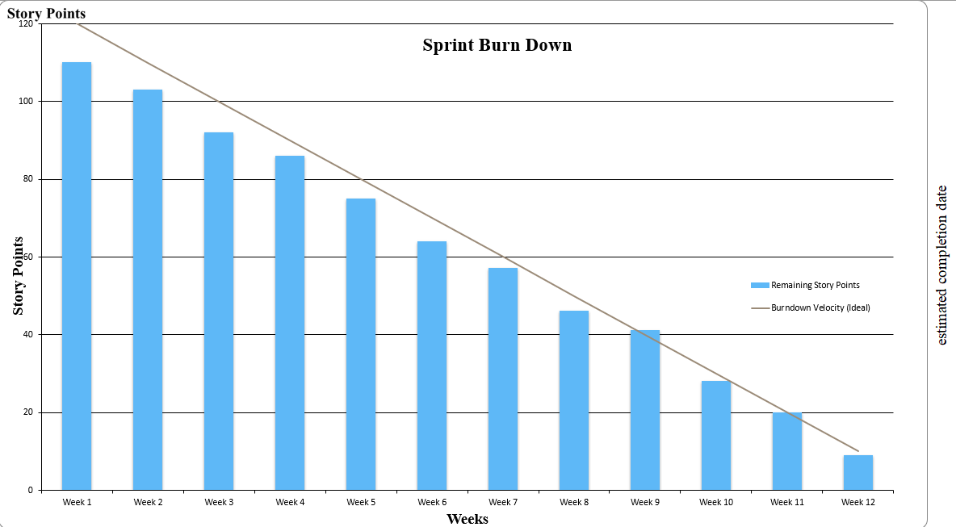

The Sprint Burndown Chart illustrates the progress of development work across 12 working weeks, structured into 5 two-week sprints. The Y-axis represents Story Points (0–120), beginning at 110 points reflecting all 30 user stories while the X-axis tracks the working weeks.
The blue bars show the remaining story points decreasing steadily each week, and the diagonal line represents the ideal burndown velocity. The chart confirms that the team's actual progress closely follows the ideal trajectory, demonstrating consistent sprint velocity in line with Agile Scrum principles (Schwaber & Sutherland, 2020). All 30 user stories are on track for completion by Week 12, the final day of Sprint 5 and the project's expected delivery date.

9. Conclusion

This report has presented the full product planning artefacts for Part 2 of the CW1 assignment for the Family Travel Companion platform, developed by Team F3 in accordance with Agile Scrum principles as outlined by Schwaber and Sutherland (2020). It has given us a clear Minimum Viable Product, a five-sprint story map, interface wireframe designs, detailed development tasks, and a complete set of thirty test cases linked to ten chosen user stories.

The MVP definition mainly revolved around five primary user stories destination search S1, shared itinerary creation S2, budget management S5, booking S4, and travel document upload S6 that together cover an entire travel planning cycle for families. This scope was intentionally limited to provide the greatest user benefits at the outset, while partner-facing, administrative, and gamification features were set aside for subsequent sprints, in line with the iterative delivery approach promoted by Beck et al. (2001). The five-sprint story map not only reflects the full backlog of thirty stories but also shows the systematic development of the core user-facing features in Sprints 1 and 2 to platform-wide integration, performance optimization, and compliance assurance in Sprint 5.
During the wireframe design phase, we followed Buxton's (2007) 3-up and 1-up sketching method for seven chosen features. This helped us to assess different design alternatives before settling on the final one. Using this systematic method allowed us to make design choices thoughtfully, rather than impulsively. For example, the hybrid list-and-map destination search, the tabbed booking experience with the persistent basket, and the folder-based document management view were all based on a design rationale instead of being first-impulse choices. The adoption of a consistent indigo/violet brand identity across all screens reinforces platform cohesion and trust, qualities identified by Johnson et al. (2024) as critical to family adoption of digital travel tools.
The development tasks produced for Sprint 2 demonstrate a technically rigorous approach to implementation planning. Each task is decomposed into clearly scoped subtasks with explicit API specifications, database schema designs, and integration requirements. The tasks deal with the architectural problems that were brought up in the Part 1 spike stories. These include real-time WebSocket synchronisation for editing itineraries together, encrypted offline storage for travel documents, and Stripe-based payment tokenisation for secure booking. The team has ensured that there is a complete vertical traceability from a stakeholder's need to an implementation and verification by connecting each development task directly to the user story and acceptance criteria.
These thirty test cases cover all the three kinds of acceptance scenarios i. e. happy path, unhappy path, and edge case, for 10 chosen user stories. This coverage makes sure that the platform's most important functional behaviors can be checked before it is released. This solves the coordination gap that the Travel Technology Association (2025) found, which said that 65% of families still have trouble coordinating travel plans digitally even though many tools are available. The test cases for collaborative editing, document upload, budget tracking, waiver management, and gamification redemption demonstrate how thoroughly various stakeholders' needs were considered when the product backlog was created.
In short, the artifacts made in this report give the software development team clear instructions for every individual sprint, design the user interfaces based on comparison of different designs, write the implementation tasks with a high level of detail, and propose a verification system based on real user requirements. From Sprint 3 to 5 when the platform is being developed, the gradual improvements in backlog, integration of partners, and use of gamification features as indicated in the story map will be changing the minimum viable product into a complete, multi-stakeholder travel companion which is actually capable to solving the problem of coordination challenges in trip planning of families by Smith and Chen, 2023; Williams and Kumar, 2024.

10. References
1. Beck, K., Beedle, M., van Bennekum, A., Cockburn, A., Cunningham, W., Fowler, M., Grenning, J., Highsmith, J., Hunt, A., Jeffries, R., Kern, J., Marick, B., Martin, R.C., Mellor, S., Schwaber, K., Sutherland, J. and Thomas, D. (2001) Manifesto for Agile Software Development. Available at: https://agilemanifesto.org (Accessed: 18 April 2026).
2. Buxton, B. (2007) Sketching User Experiences: Getting the Design Right and the Right Design. San Francisco: Morgan Kaufmann.
3. Johnson, P., Williams, S. and Chen, L. (2024) ‘Digital transformation in family travel: A comprehensive analysis of user needs’, Journal of Tourism Technology, 15(2), pp. 112–128.
4. Schwaber, K. and Sutherland, J. (2020) The Scrum Guide: The Definitive Guide to Scrum – The Rules of the Game. Available at: https://scrumguides.org
5. Smith, R. and Chen, M. (2023) ‘Collaborative travel planning: Challenges and opportunities for digital platforms’, International Journal of Hospitality and Tourism, 28(4), pp. 301–319.
6. Travel Technology Association (2025) Family travel technology report 2025: Digital tools and user behaviour. Washington, DC: Travel Technology Association.
7. Williams, D. and Kumar, A. (2024) ‘Legal compliance in travel technology: Digital waivers and data protection’, Tourism Law Quarterly, 12(1), pp. 45–62.

11. Appendix

This appendix contains the team meeting minutes recorded throughout the CW1 Stage 2 project lifecycle, along with Trello board screenshots evidencing Sprint 2 progress. All meetings were conducted in accordance with the Agile Scrum ceremonies outlined by Schwaber and Sutherland (2020), with the Scrum Master (Habibur Rahman) facilitating each session and maintaining the Trello board as the primary sprint management tool.

Appendix A – Meeting Minutes

Meeting | Meeting 1 – Project Kick-off and Role Assignment
Date | 26 March 2026
Time | 14:00 – 15:00
Location | Zoom (Online)
Attendees | All six members: MD Ali Hasan Jidan, Habibur Rahman, Md Jahirul Islam, Komalpreet Kaur, Sheheryar Khan, Syed Abdul Hafeez

Agenda and Outcomes
The team had their first kick off meeting, which set the project groundwork for CW1 Stage 2. Tasks were allocated to team members, with the duties being officially assigned as reported in Section 1. Scrum Master, Habibur Rahman, was appointed and been confirmed. The task of Scurm Master was to enable all sprint ceremonys, also keep the Trello Board up to date. The Agile Scurm workflow was provided to the team as relates to Scrum Guide (Schwaber and Sutherland, 2020).

Key decisions made:
- Trello board developed by me which has four columns listed as Sprint Backlog, In Progress, Review and Done.
- All the 30 user stories from Part 1 placed on the Sprint Backlog column as individual Card.
- Drafting of MVP taken up by Md Jahiruls Islam; story map skeletons to Habibur Rahman and Komalpreet Kaur.
- Weekly meeting schedule agreed: every Saturday at 13:00 with ad hoc online check-ins as needed.
- Established methods of contact: Whats App group for daily contact, and Zoom for the formal weekly meetings.
Meeting | Meeting 2 – Sprint 1 Planning and Wireframe Assignment
Date | 30 March 2026
Time | 13:00 – 14:30
Location | Online
Attendees | All six members present

Agenda and Outcomes
Following Sprint 1 planning, the stories were transitioned officially into the In-Progress section of the Trello board. The team examined the assignment brief specifications, (preparation for wireframe creation) and allocated feature specific jobs to individual team members. The 3-up and 1-up sketching process was presented by the team leader and adopted as the basis of the team's approach for the project. (Buxton, 2007)

Key decisions made:
- Sprint 1 stories S1 (Search destinations), S2 (Shared itineraries), S5 (Manage budgets), and S6 (Upload documents) moved to In Progress on Trello.
- Wireframe assignments distributed: Feature 1 – Search Destinations assigned to the full team; Features 2–7 assigned individually as per Section 5 of the report.
- Spike stories 1–4 (Real-time sync, Promotion rules, Offline storage, Scalable storage) added to the Trello board and assigned.
- Brand colour indigo/violet (#4F46E5) agreed for consistent use across all wireframe designs.
- Each member tasked with completing 3-up concept sketches before Meeting 3.

Meeting | Meeting 3 – Wireframe Peer Review and Design Rationale Discussion
Date | 3 April 2026
Time | 14:00 – 16:00
Location | Online
Attendees | All six members present

Agenda and Outcomes
Each team member presented their individual 1-up wireframe designs for Features 2–7 to the group for peer review and feedback. Design decisions were discussed and final selections confirmed for each feature. Following the wireframe review, the team conducted a technical workshop to draft development tasks for user stories S1 and S4, decomposing each into clearly scoped subtasks with explicit API specifications and database schema designs.

Wireframe decisions confirmed:
- Feature 2 (Book Accommodations) – Habibur Rahman's tabbed design unanimously.
- Feature 3 (Upload Documents) – MD Ali Hasan Jidan's folder-view design selected over member-centric view.
- Feature 4 (Budget Dashboard) – Md Jahirul Islam's progress-bar layout confirmed as final.
- Feature 5 (Group Trips) – Komalpreet Kaur's RSVP-plus-conflict-detection dashboard selected.
- Feature 6 (Shared Itineraries) – Sheheryar Khan's collaborative timeline approved.
- Feature 7 (Rewards Store) – Syed Abdul Hafeez's expiry-alert rewards design confirmed.

Development tasks workshop outcomes:
- Tasks T1–T6 covering S1 (Search for Destinations) drafted: database schema, RESTful API, map component, UI build, offline fallback, and integration tests.
- Tasks T7–T12 covering S4 (Book Accommodations) distributed for individual drafting.
- Sheheryar Khan performed a consistency check ensuring all tasks link to Part 1 acceptance criteria.

Meeting | Meeting 4 – Test Case Drafting Session and Sprint 2 Planning
Date | 8 April 2026
Time | 13:00 – 14:30
Location | Online
Attendees | All six members present

Agenda and Outcomes
The team reviewed the test case structure template and confirmed the three scenario types required for each of the ten selected user stories: happy path, unhappy path, and edge case. Test case assignments were distributed across all members. Sprint 2 planning was then conducted, with active stories formally moved to In Progress on the Trello board.

Test case assignments confirmed:
- Team test cases: S1, S2, S4, S5, S15 – coordinated by Habibur Rahman.
- S6 – MD Ali Hasan Jidan; S7 – Habibur Rahman; S11 – Md Jahirul Islam.
- S16 – Komalpreet Kaur; S21 – Sheheryar Khan; S27 and S28 – Syed Abdul Hafeez.
- Each test case must include: Step ID, Step Description, Test Data, and Expected Result columns.

Sprint 2 planning outcomes:
- S4 (Book travel services), S15 (Coordinate group trips), S6 (Upload documents), and S7 (Digital albums) moved to In Progress.
- Spike 2 (Promotion rules) and Spike 4 (Scalable storage) added to In Progress for concurrent investigation.

Meeting | Meeting 5 – Quality Assurance and Report Consistency Review
Date | 14 April 2026
Time | 14:00 – 15:30
Location | University Class Room
Attendees | All six members present

Agenda and Outcomes
Sheheryar Khan, acting in his Quality Checker role, led a comprehensive consistency review of all report artefacts prior to final submission. The review covered all sections of the report to ensure alignment between user story IDs, acceptance criteria, wireframes, development tasks, and test cases. The conclusion section was drafted collectively and reviewed by all members.

Quality checks performed:
- All user story IDs verified as consistent across the story map (Section 4), wireframes (Section 5), development tasks (Section 6), and test cases (Section 7).
- All 30 test cases verified to match their corresponding acceptance criteria from Part 1.
- All seven wireframe design rationales confirmed at approximately 250 words each.
- Harvard-style references checked for completeness and correct formatting throughout.

Meeting | Meeting 6 – Sprint 2 Review and Final Submission Sign-off
Date | 18 April 2026
Time | 13:00 – 14:30
Location | Online
Attendees | All six members present

Agenda and Outcomes
The final Sprint 2 review was conducted and the completed report was circulated and approved by all six members. All Sprint 2 Trello cards were moved to their correct final columns and the board screenshot was captured for inclusion in this appendix. The submission was then completed by Komalpreet Kaur via the module portal.
Sprint 2 review outcomes:
- S4 (Book travel services), S15 (Coordinate group trips), S6 (Upload documents), S7 (Digital albums), Spike 2 (Promotion rules), and Spike 4 (Scalable storage) all moved to Review/Done on Trello.
- Spike 1 (Real-time sync), Spike 3 (Offline storage), S5 (Manage trip budgets), and S1 (Search for destinations) confirmed in Review column.
- All report sections confirmed complete: team contributions, introduction, MVP, story map, wireframes, development tasks, test cases, conclusion, and references.
- Habibur Rahman captured the final Trello board screenshot for inclusion in Appendix B.
- All six members confirmed approval of the final document.
- Komalpreet Kaur submitted the final report via the module portal before the deadline.
- Team agreed to reconvene at the beginning of the next sprint cycle to commence Sprint 3 planning.

Appendix B – Trello Board Screenshots

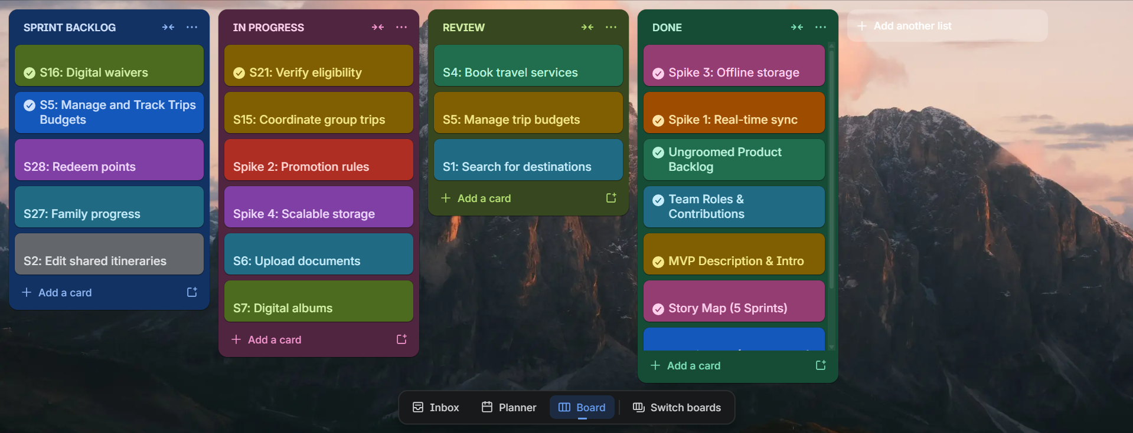

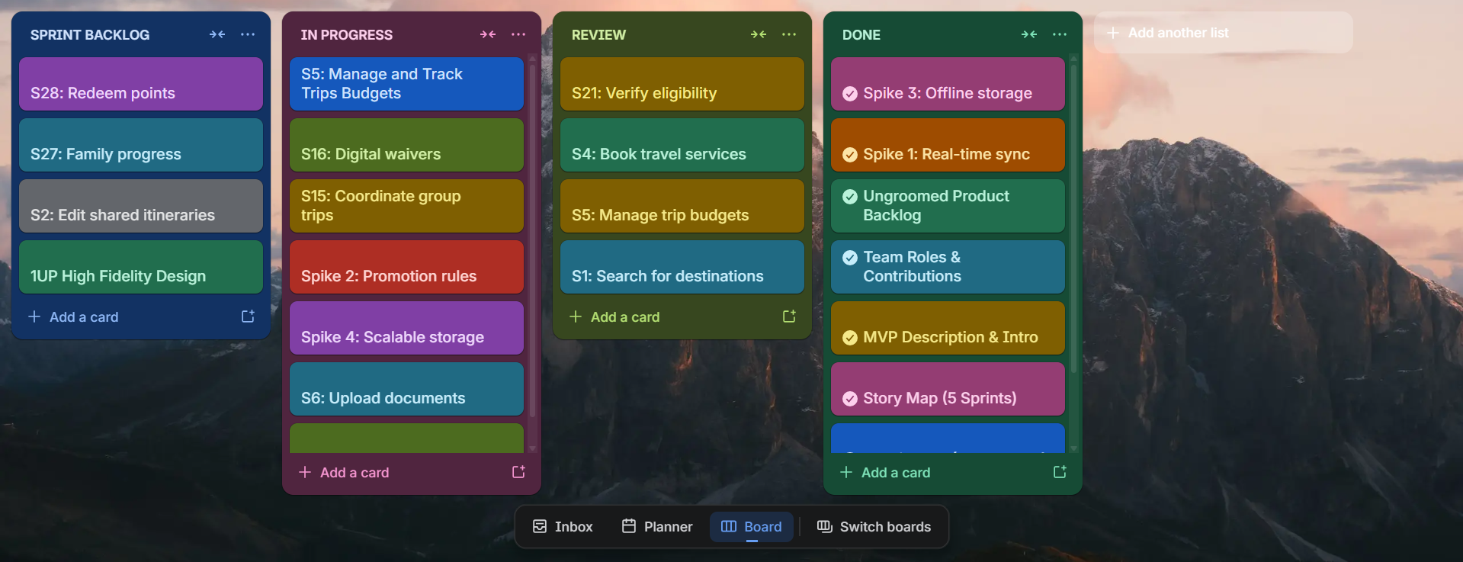

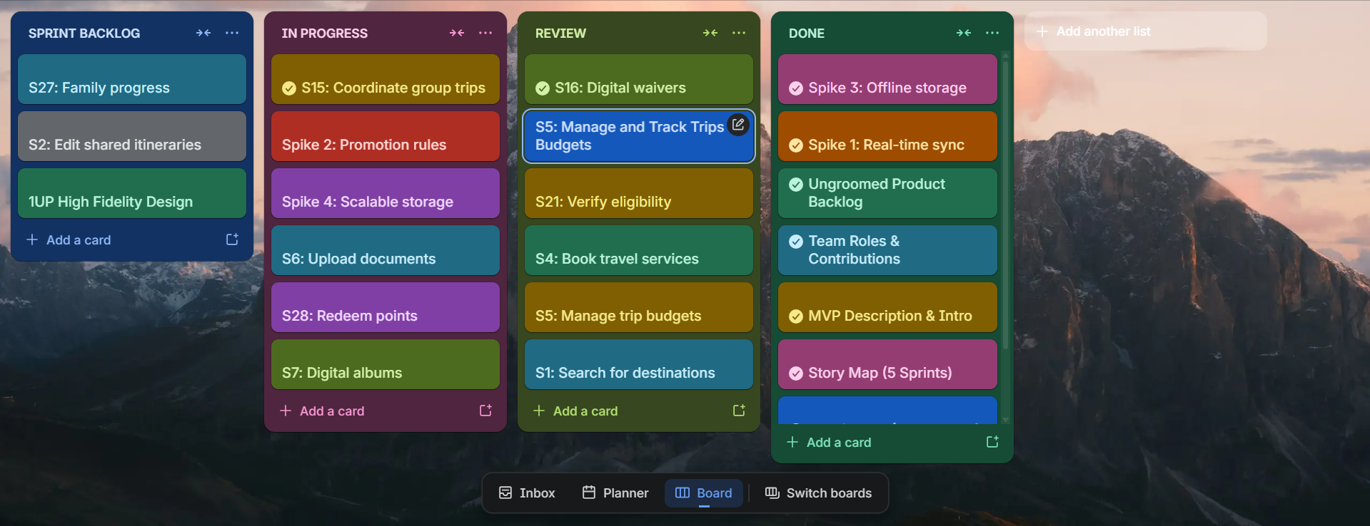

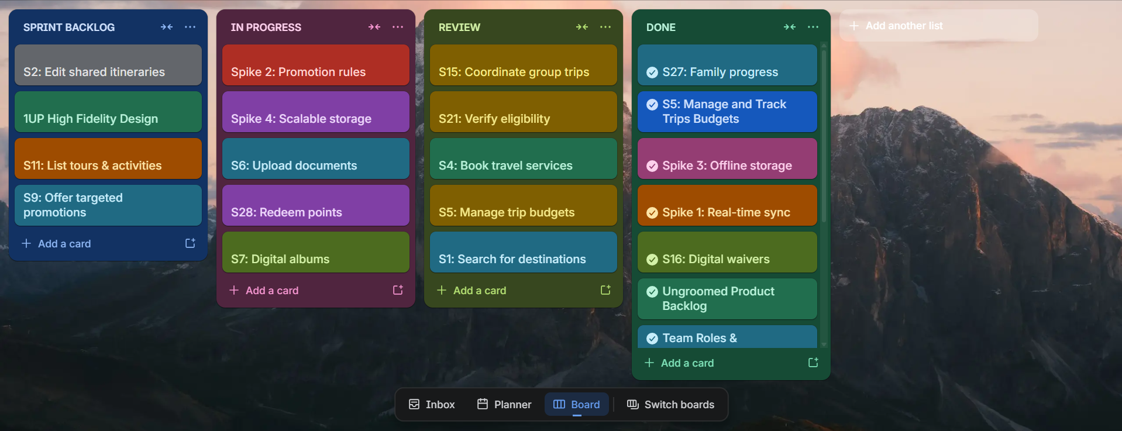
Figure B1 – Trello Board: COM435 – F3 – Family Travel Companion CW1 Stage 2

